Title

Web programming class project 2021/2022

|  |  |  |  |  |
| --- | --- | --- | --- | --- |
| Student Name in English | Student Name in Arabic | Student ID | Section | Work percentage |
| Jenan Abualrub | جنان أبو الرب | 1924400 | Sun 8-9:30 | 50% |
| Mayar Abdulkareem | ميار عبد الكريم | 11924955 | Sun 8-9:30 | 50% |
|  |  |  |  |  |

Date/time

---------------------------------------------This section is intended for the Instructor---------------------------------------

|  |  |
| --- | --- |
| **Topic** | **Mark** |
| Project Idea |  |
| Project Complexity |  |
| Project Tools |  |
| Project Requirements and Modeling |  |
| Project Discussion |  |
| Project Completeness |  |
| Project Output Results or reporting |  |
| Project Administration and Management |  |
| Project Report |  |
| Team work |  |
|  |  |
|  |  |
|  |  |
|  |  |
|  |  |

Abstract:

The project presents a website ran by a veterenity clinic. It hosts homeless pets and helps them find their new home. It also provides different items (food, toys, collars and bowls) and other items a person might want to bring back to their pets. The clinic also allows pets owners to book appointments with our professional vets to help the pets recover. Since being a vet is an absolute pleasure for many, new members are welcomed by the approval of the manager.

Introduction:

The website sells pets’ products and offers lovely pets for adoption. New customers are welcomed to scroll through our items, but a sale can only be made when the user creates their account. The account can always be edited back, the user shall feel free to update their data.

The website suggests a list of pets that are ready to be adopted, if the user is hesistant, they can easily ask about any of our pets. Once the user confirms their desire to adopt one of the pets; their name will be assigned as the owner of that pet, and they’re welcome to come to clinic and bring it home.

It’s invetibale that a pet owner wants to buy pets’ products, that’s why we offer items of different categories to satisfy our client. To eaze the process of finding what they are looking for, the client can simply use the search bar to search for a specific item, or click the filtering button and choose the list of items’ types they want to see on their screen. Food items are offered in different sizes to help the client choose the suitable size for their pets. Other items are offered in different colors, thus, a client chooses the color that matches their pets more.

Considering that more than one item might be bought at once, the client can fill up a cart of items, and a cart on the top of screen will be showing the number of items selected so far. The client can always open the cart and check the items added. Once the cart is bought, the client can keep track of it using the “order” interface. The client can also book appointments with our specialists.

The employees on the other hand are capable of adding new pits to the existing list. They can also add new items to the system, and able to edit predefined items. They can also confirm or decline requested appointments coming from the clients’ side. Also, it’s their responsibility to update the status of orders made by clients. The employee is also free to edit their profile.

The manager is capable of viewing the number of items left in the stock. She can also view the percentage of each order in terms of the income it offered the clinic with in comparison with other orders. The manager is also able to hire new vets and edit salaries.

Project requirements:

This project exhibits a clinic and a pet store. It stores items, pets, users of different roles(manager, vets, clients) and allow them interact based on a set of offered functionalities.

* User: each user has their: **ID(Primary key)**, Fname, Lname, email, password, phone, address and role stored in the database.
* There are 3 types of users; manager, vets, clients.
* Manager can access employees information and edit their salaries. She can also view the companies sales. And she’s capable of hiring and firing employees.
* Vet: each vet is capable of adding and editing items in the system. They can also add new pets when available. A vet also send confirmation or an apology for an appointment request handed over from the client.
* Client: a client can buy items, adopt pets, edit their carts and keep track of the orders they’ve made previously.
* Item: each item has its **ID**(primary key), name , type, the pet it was made for, the size or color, the quantity of left samples, and its price. To prevent any inconvenience, some details are provided for each item.
* Cart: each cart is marked by its owner, a cart shall be avialbe when the user logs into their account after some time. A cart also keeps a list of selected items and the price of each in a discrete table so the user can view it easily. A cart is either bougt or still hanging. Once a cart is bought, it’s then added to the list of orders in the system.
* Order: any bought cart is said to be an order as the client has made an official agreement on buying it. each order has the location its reaching for and the status of that order at a specific time.
* Pet: each pet in the system has its data stored such as; **ID**, name, color, age, type and some details talking about the pet’s nature.
* Appointment: the client can easily choose a time that suits them to visit the clinic, thus they choose an appointment that suits the and the employee gets to accept or apologize among the appointment. The request is sent to the vet and also carries the news of new replies.
* Home: the manager has the privillage to edit the home page of the website.
* Tools:

|  |  |  |
| --- | --- | --- |
| Pic | Name | Notes |
| JetBrains PhpStorm Logo Vector (SVG, PDF, Ai, EPS, CDR) Free Download -  Logowik.com | PHPStorm | To write the code |
|  | Xampp | To run the PHP code and for Maria data base (server side) |
|  | Draw I. O | To draw the ER model |

Interfaces:

Client:

Home page

When the user log in to the website, he/she will see the following parts:

The navbar which is implemented using Bootstrap 5, this Navbar allow the website to collapse if the user shrink the window size

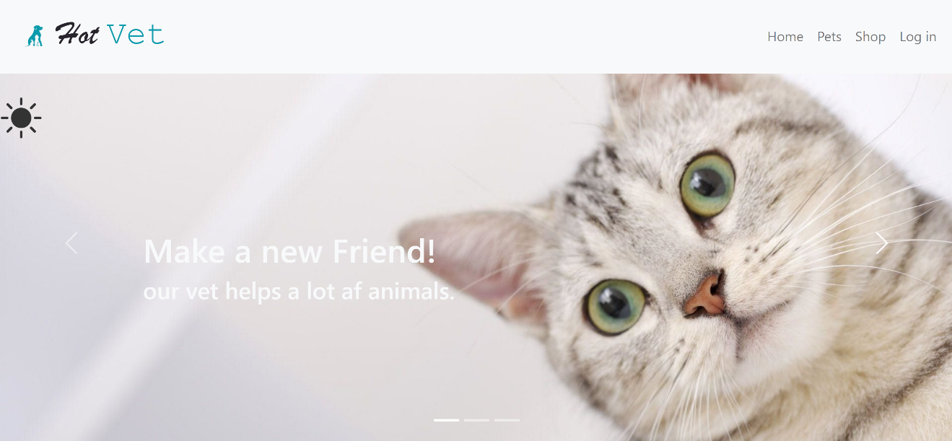

This is how it looks like

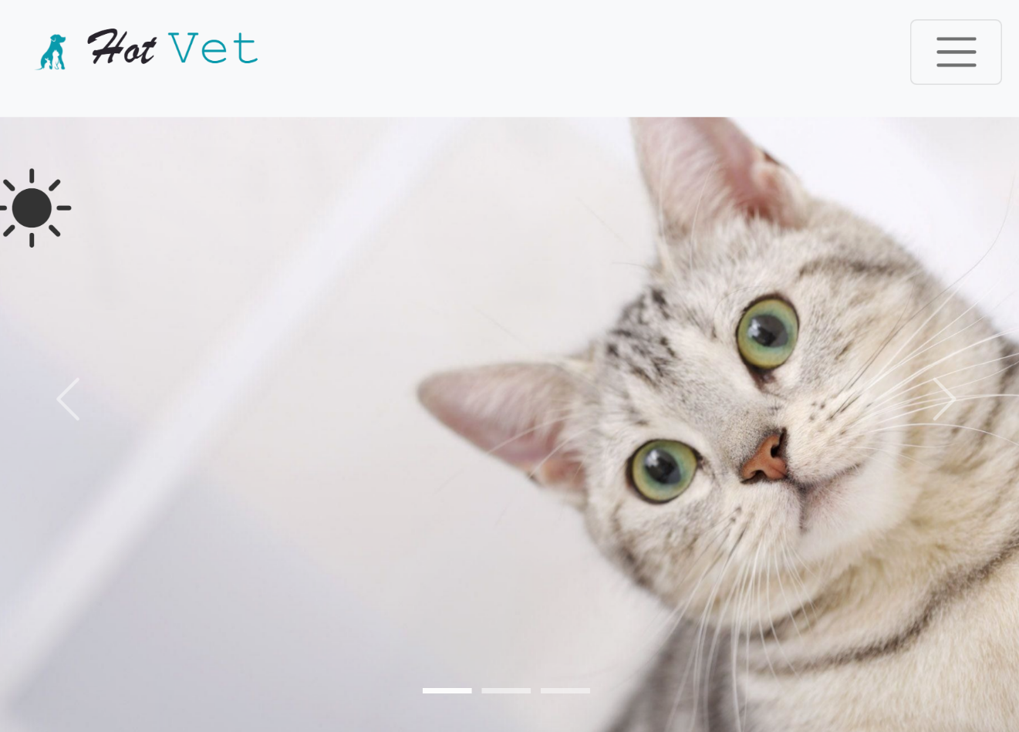

The user could see the Nav item if he/she clicks to the toggler button

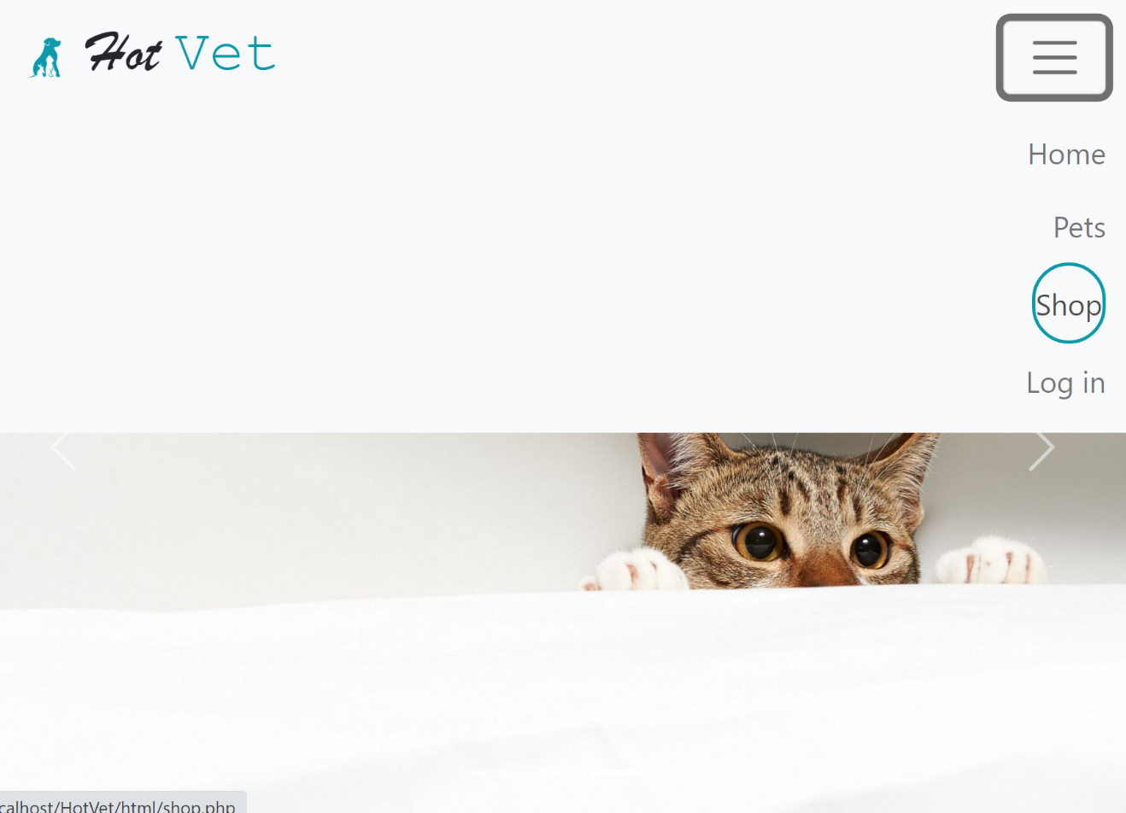

A carousel was implemented in the home page to display different images related to our clinic.

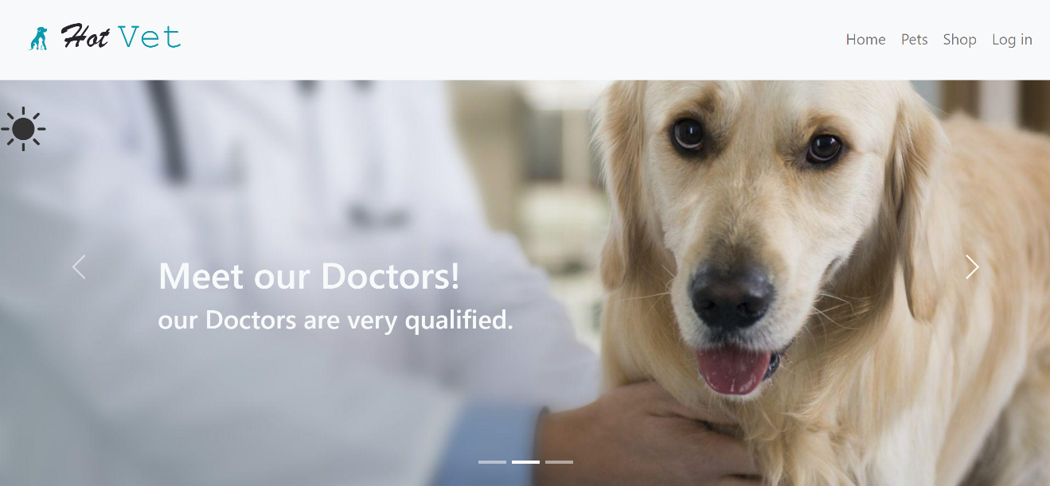

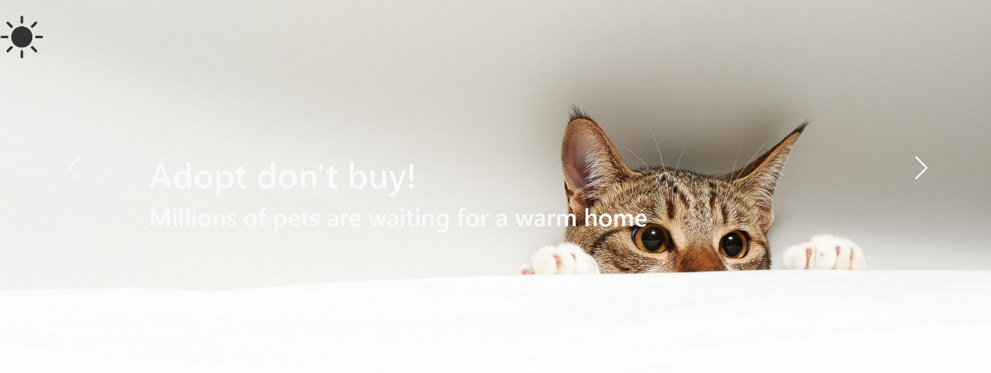

Then some information will reveal talking about our vets, and why you should use the hot vet. about our website. To make the text reveal not suddenly appear to the screen we use Scroll Reveal library.

Note that this information is uploaded from the data base dynamically, so we can allow the admin to change the content of the home page.

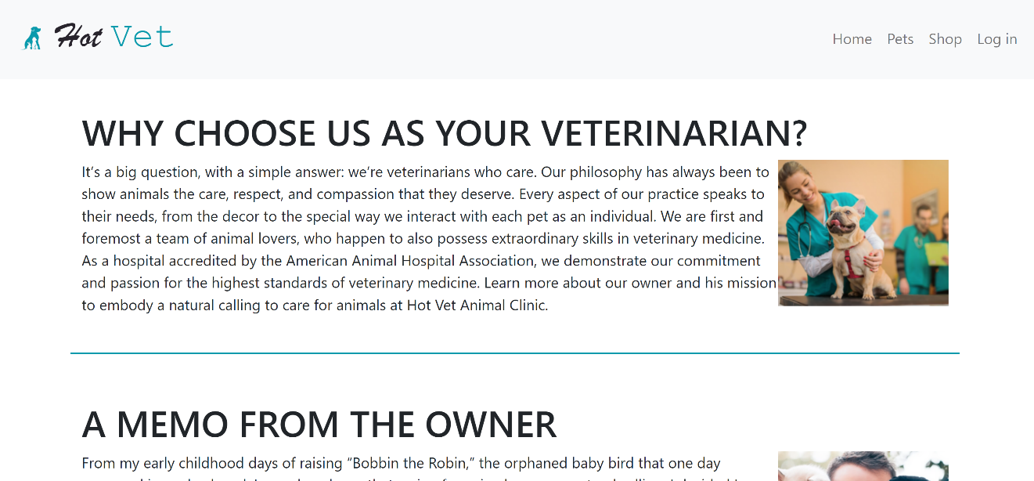

We make sure that our website is responsive, so as you can notice that the two content of text doesn’t interfere with each other.

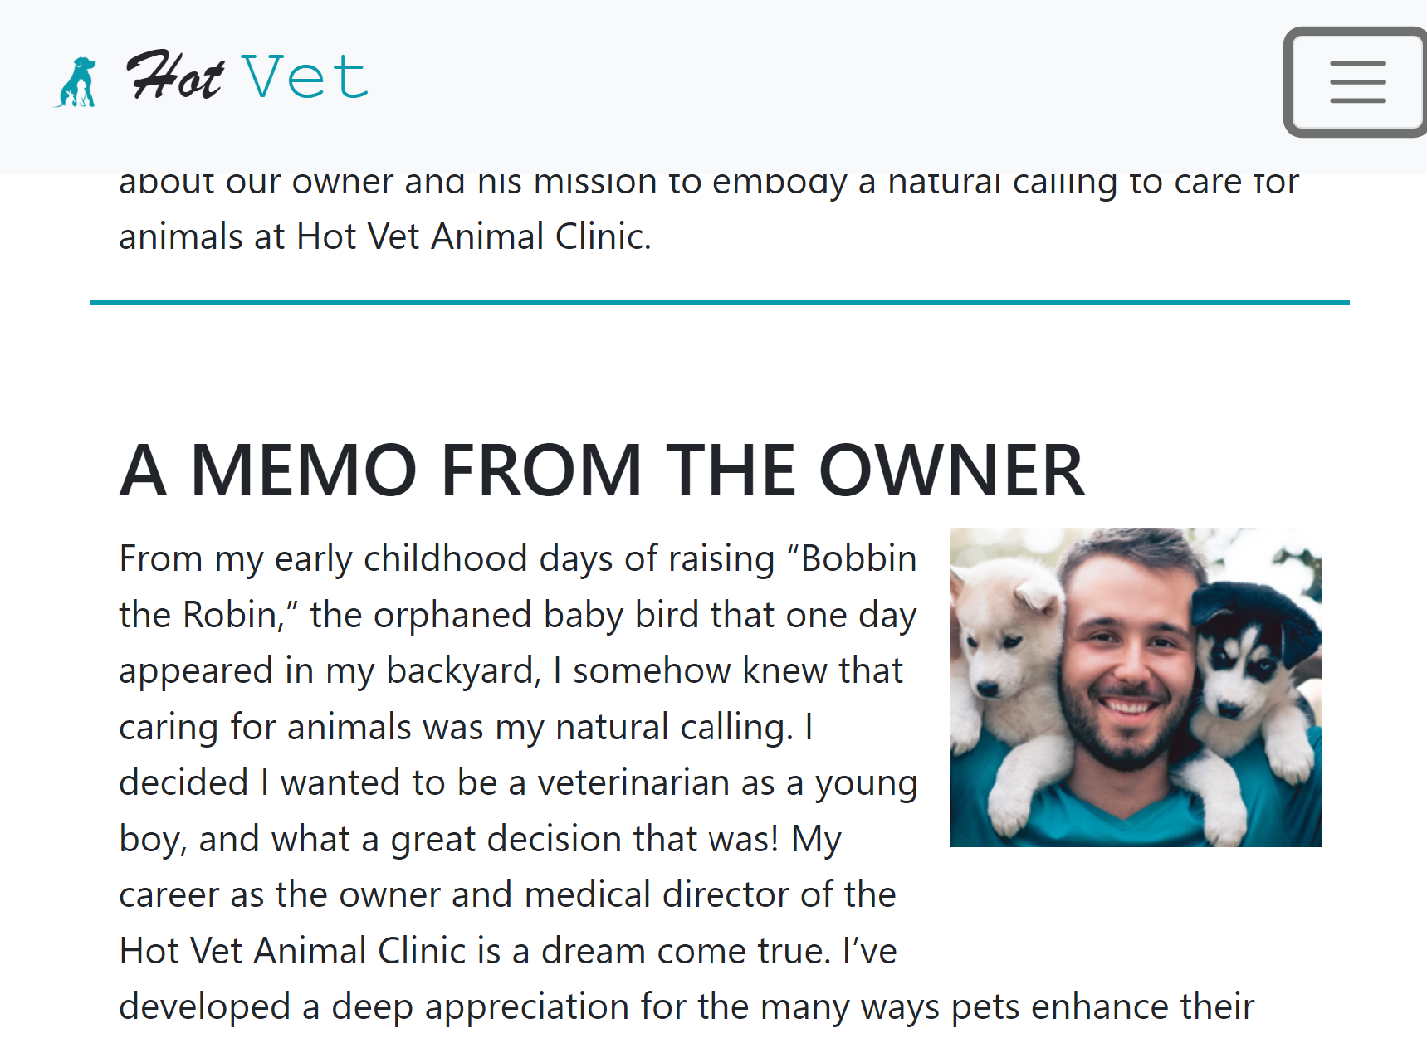

And then an introduction about our vets. A Flip cards will appear dynamically also, nothing is static in our home page.

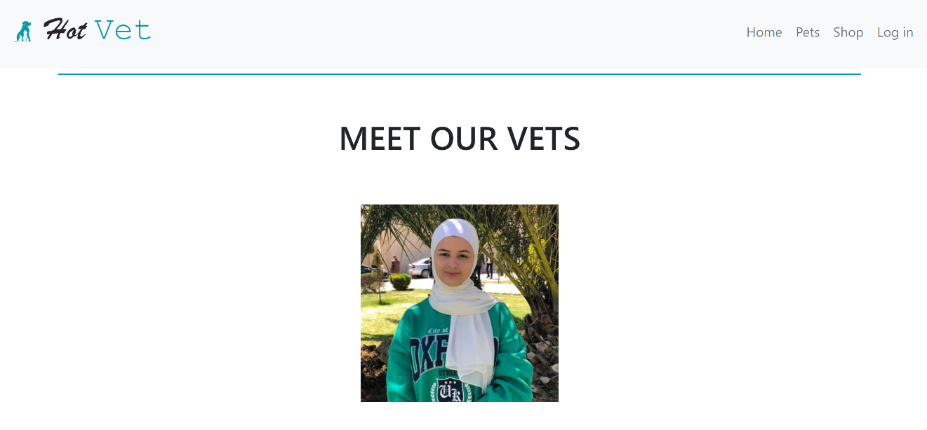

When the user hover, the flip cards will rotate to show the content with links to reach the vets.

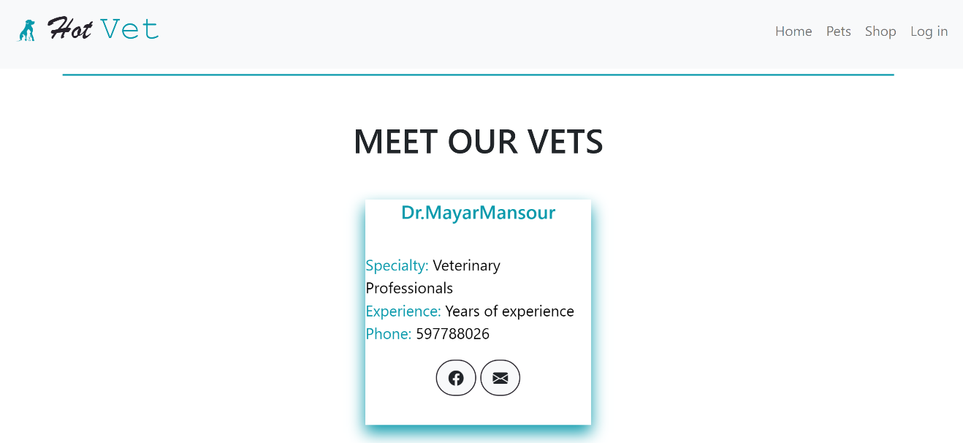

To contact us, we provide our users with the needed informarion and links in a neat way.



LOG IN:

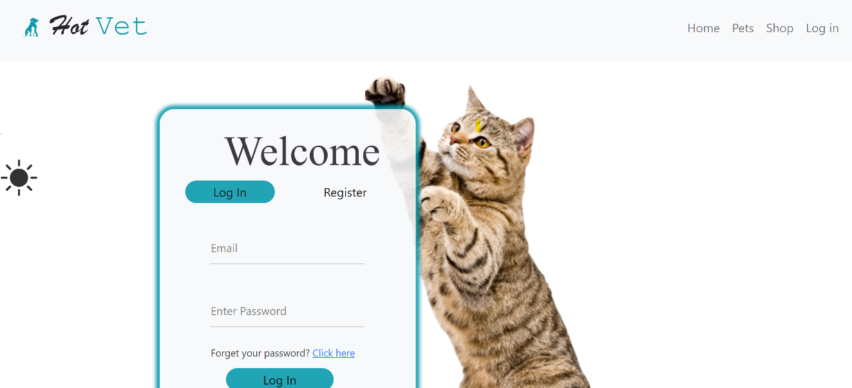

When scroll down

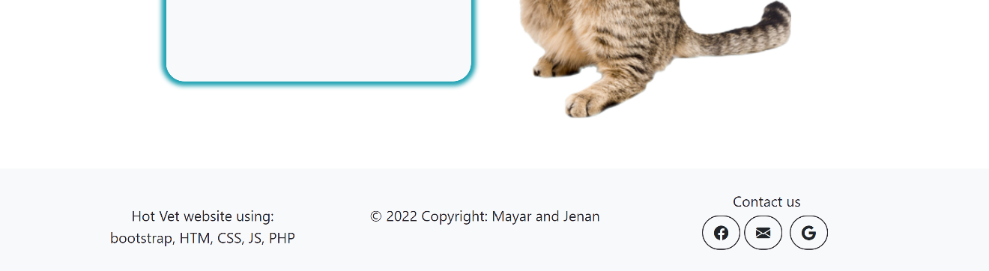

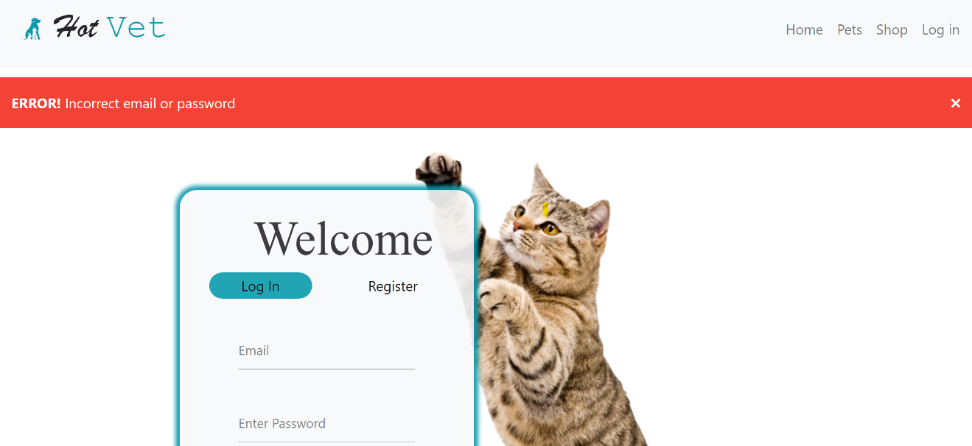

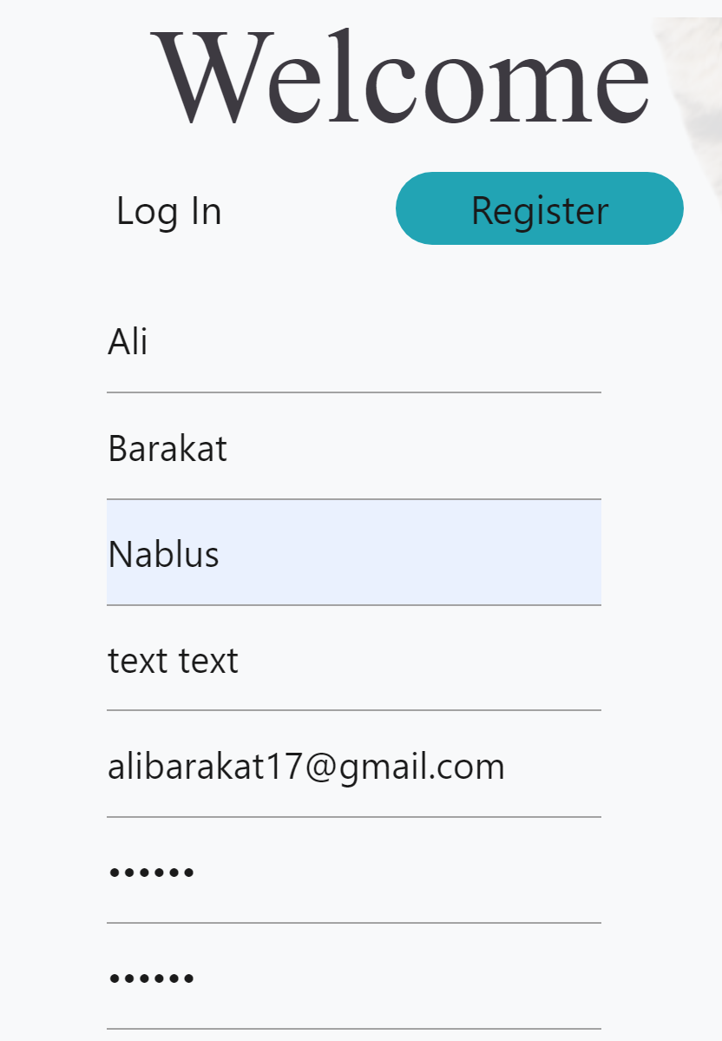

Result

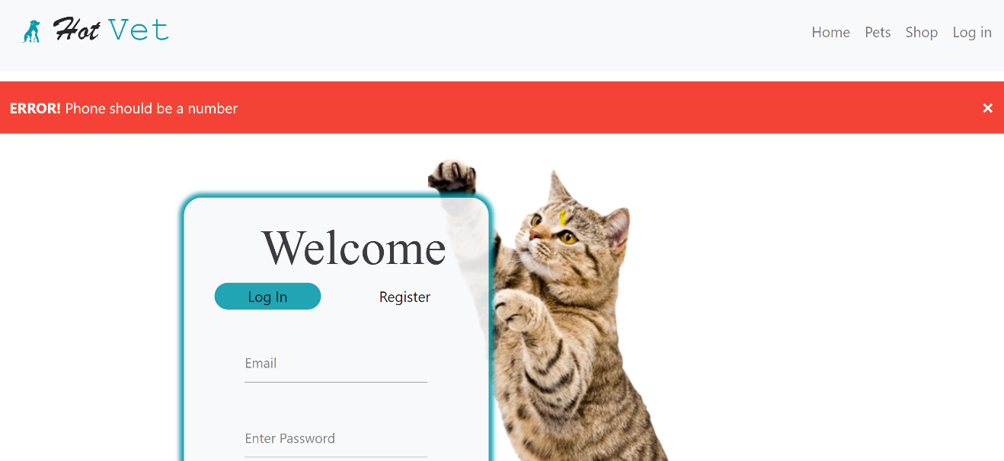

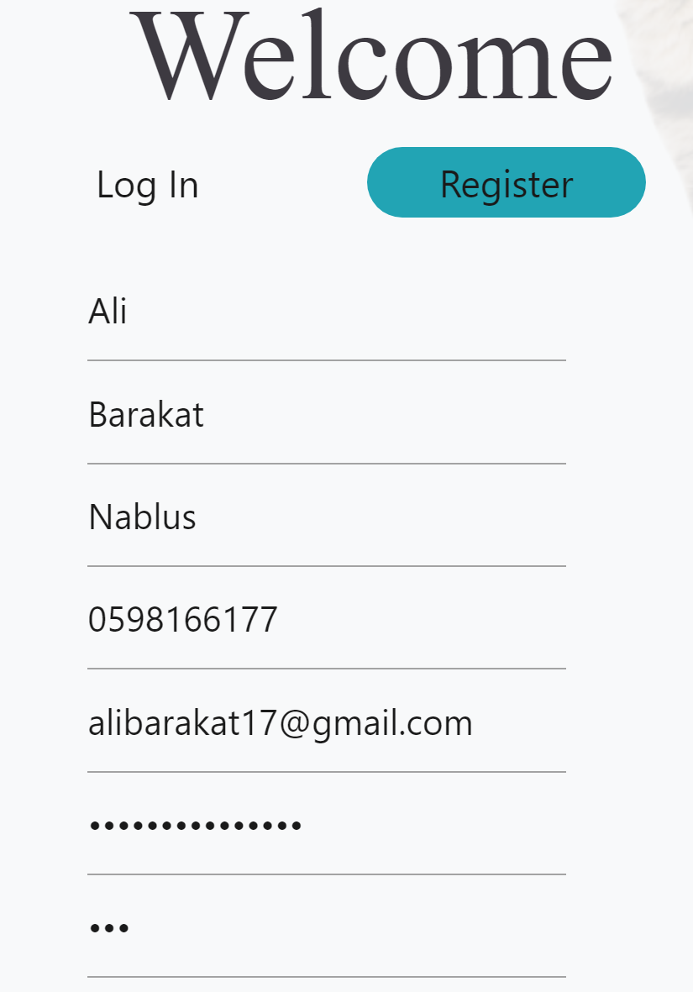

Result

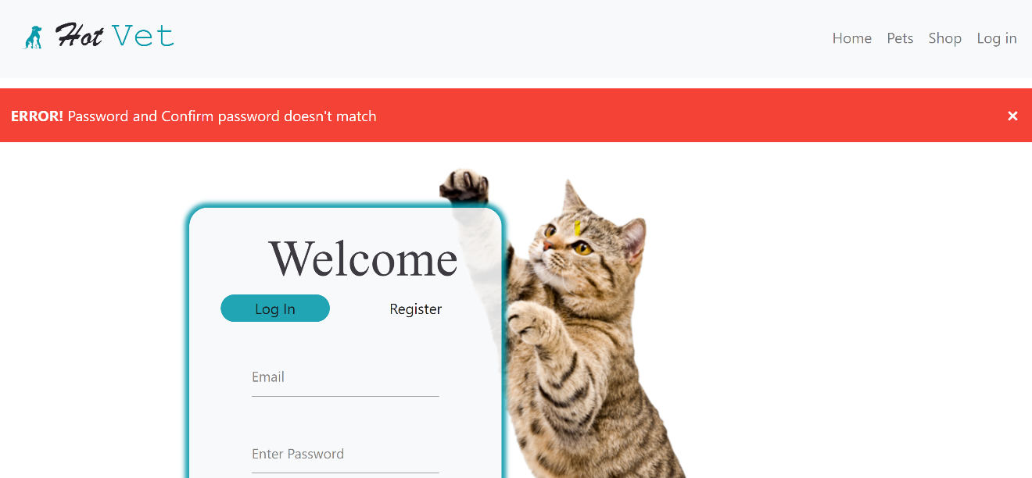

Less that 6 char

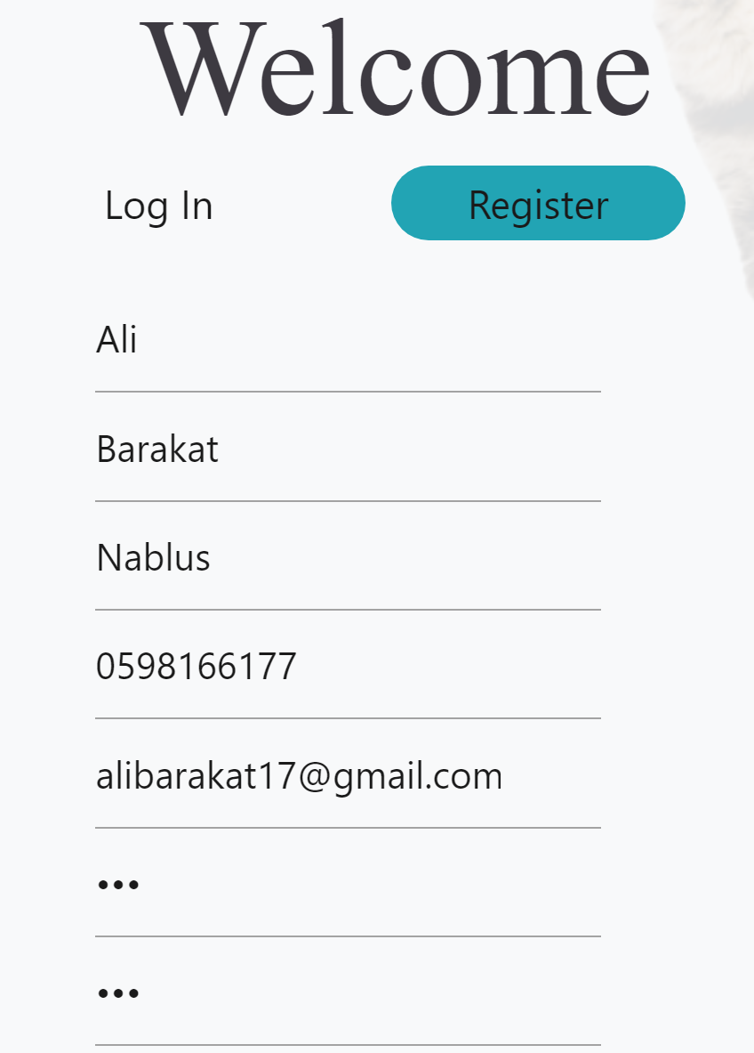

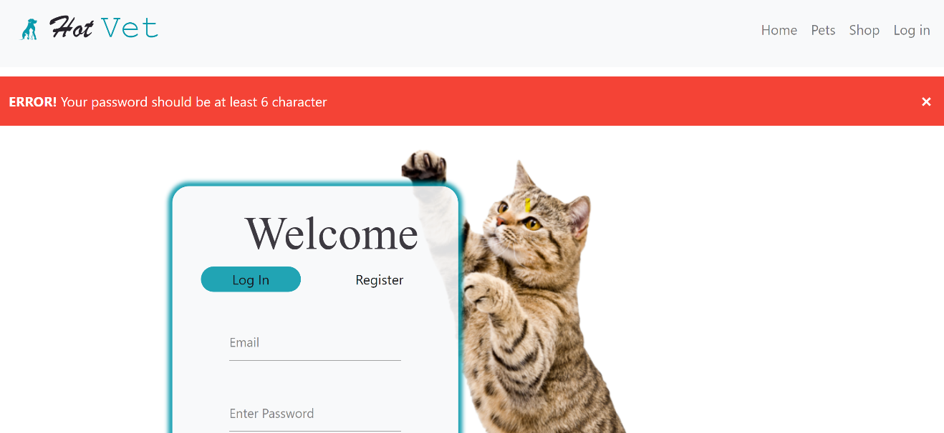

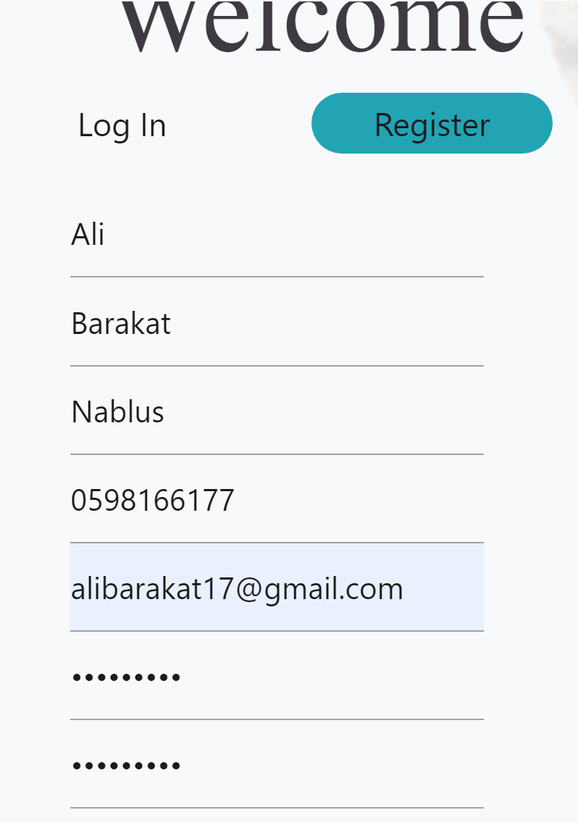

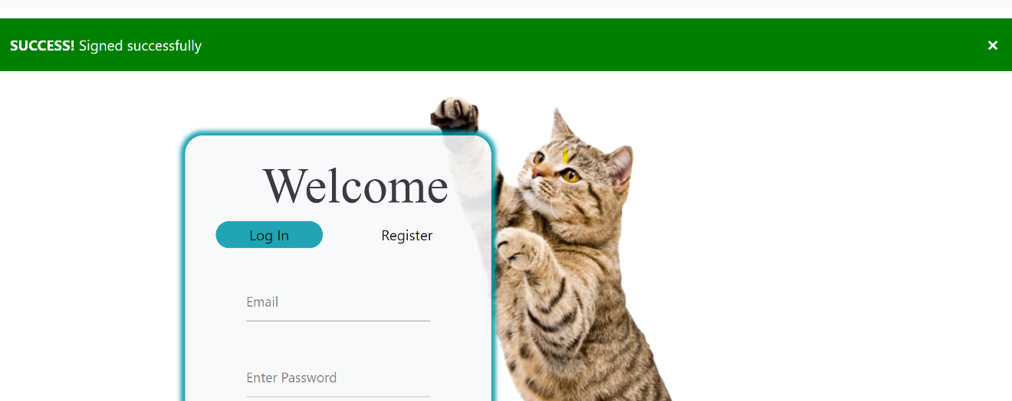

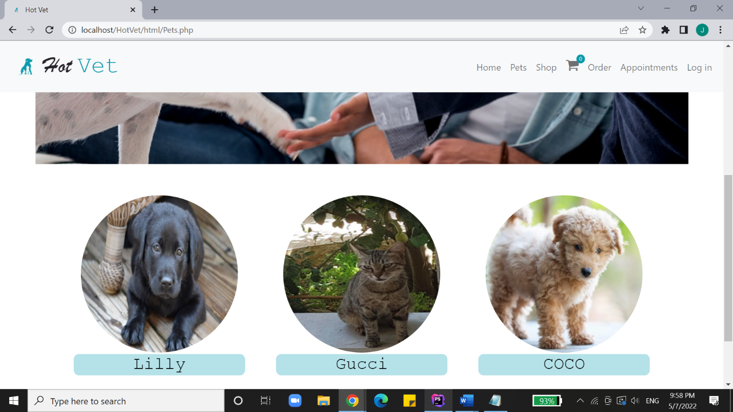

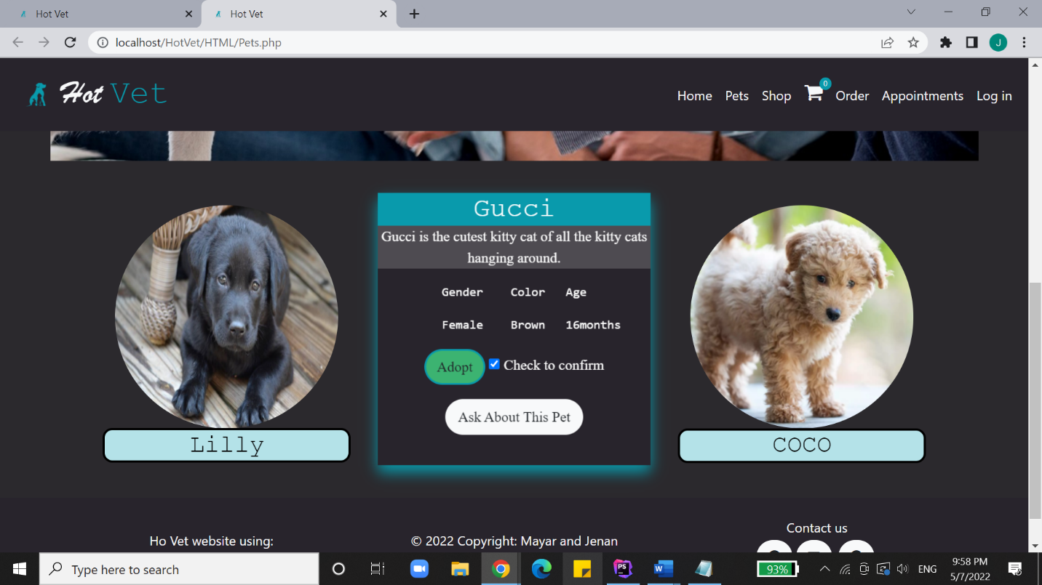

This is the interface where the user gets to view the available animals. By hovering over any of the pictures, the card flips so the user can read more about the animal and maybe decide to adopt it.

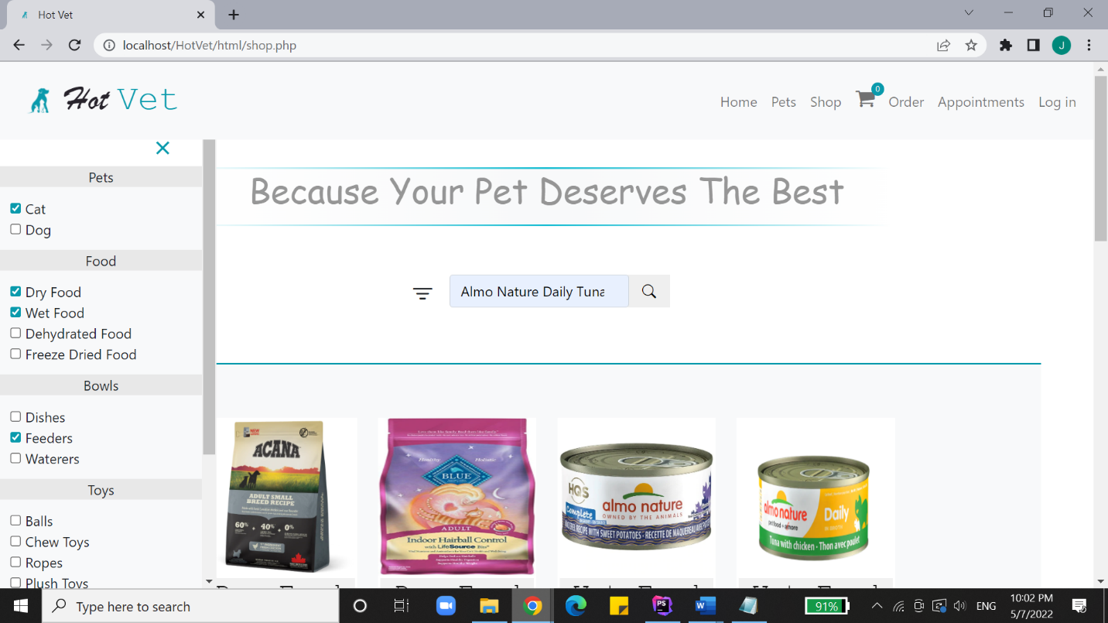

In this interface, the user is able to search for an item by anme. Also, the menu bar on the left helps filtering the items to find the type looked for.

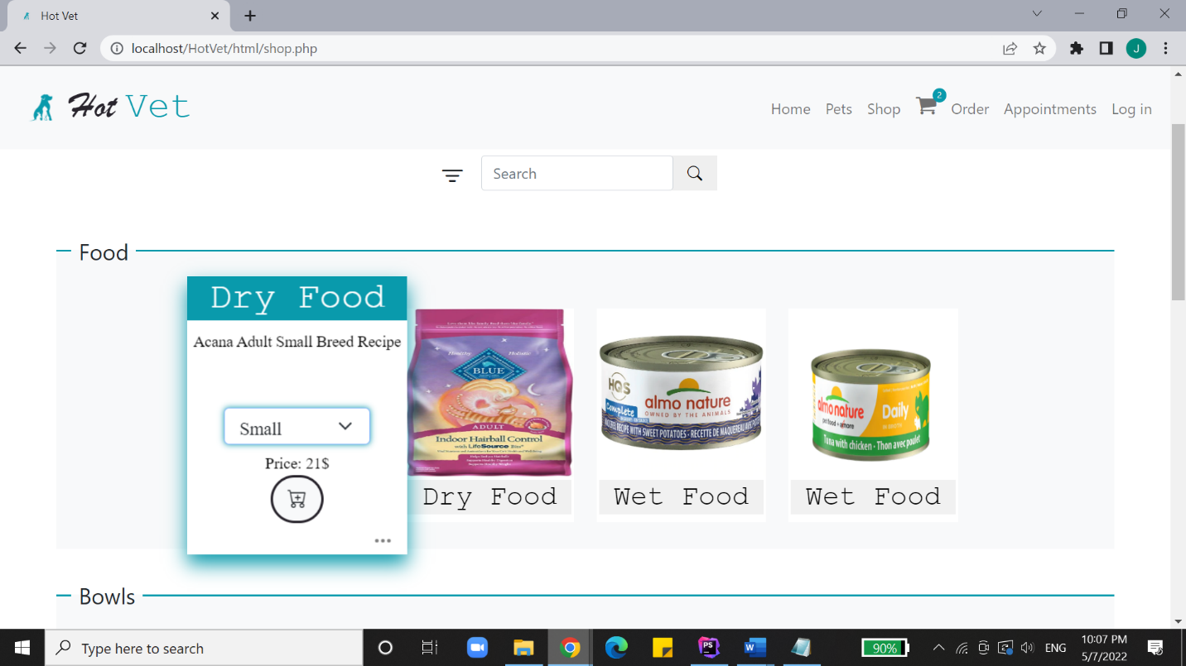

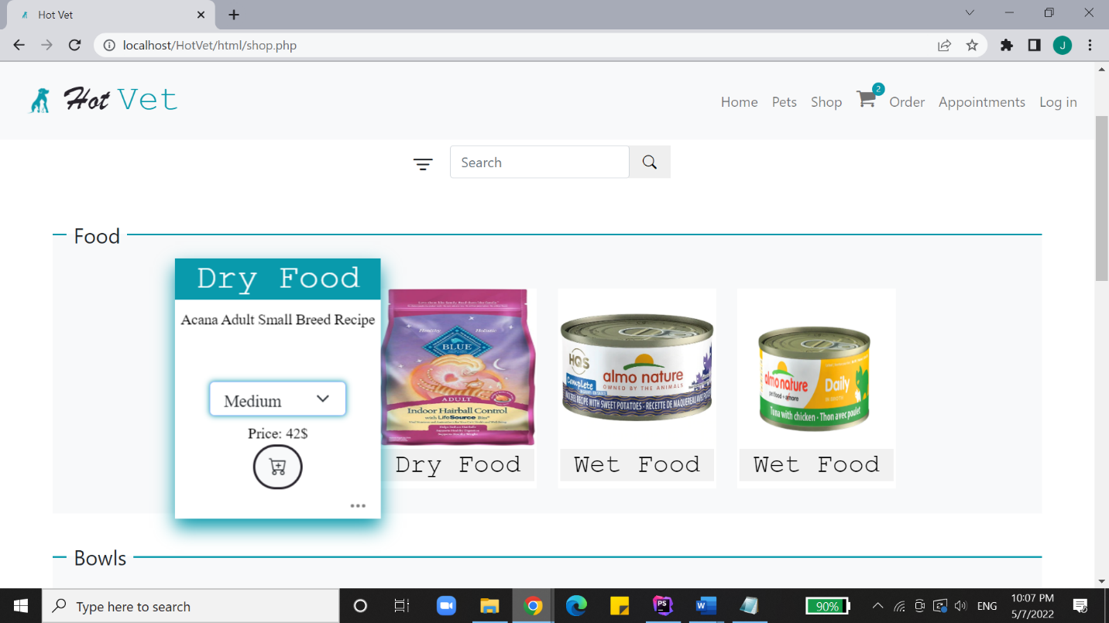

The size of the item can be chosen by the user, the price changes accordingly and momentarily.

To read more about an item, the three dots are clicked and this section appears.

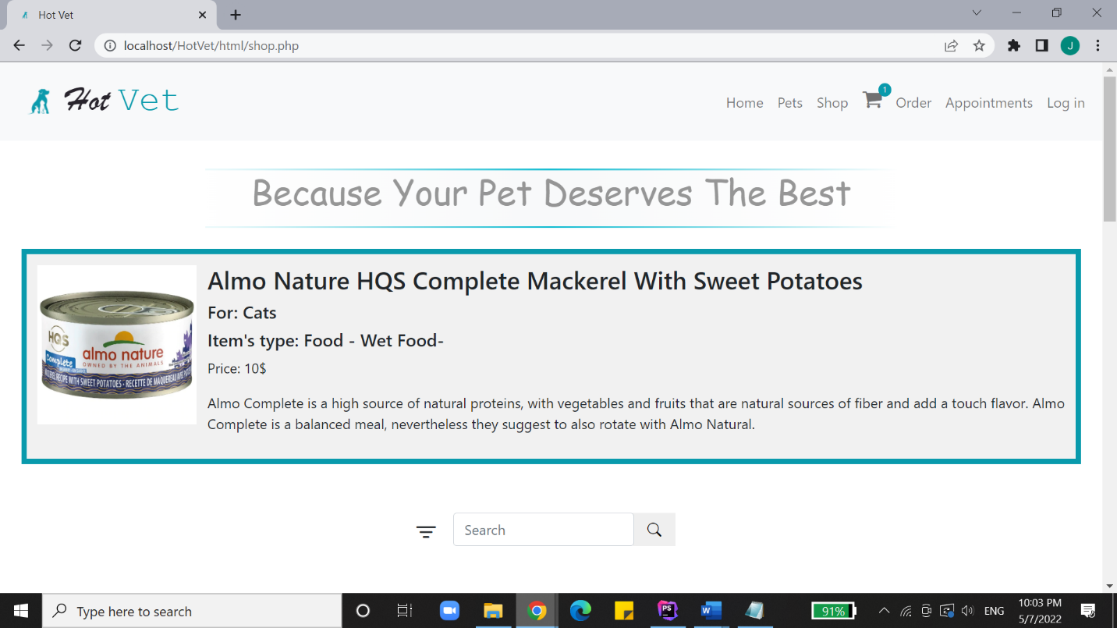

The same section appears when an item is searched for and found the system. 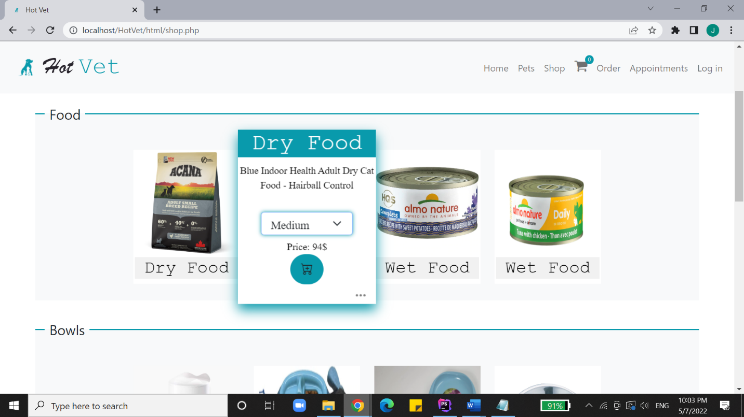

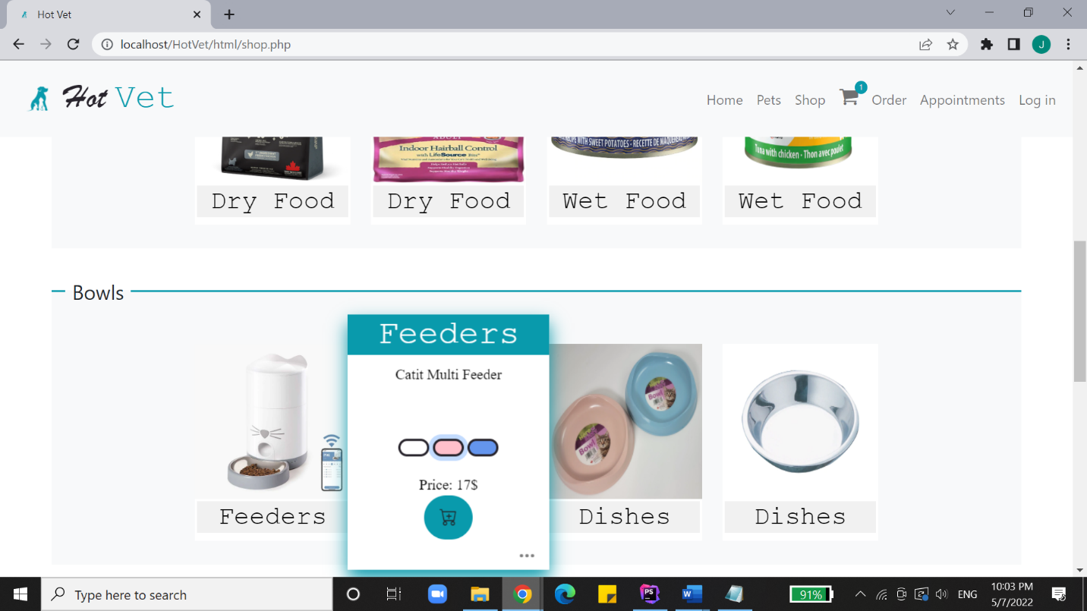

Each item has its specifications, once an item is added to the cart, the counting cart at the upper menu increments by 1.

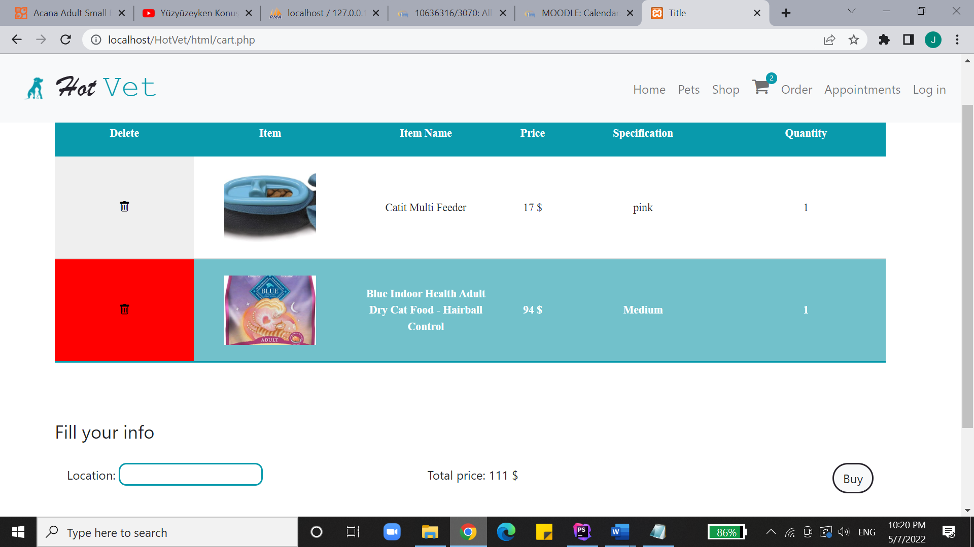

When the user decides to view the cart, they are able to view each item and its price. The red trash icon helps delete unwanted items. The form at the end is filled when the user decides to by the cart.

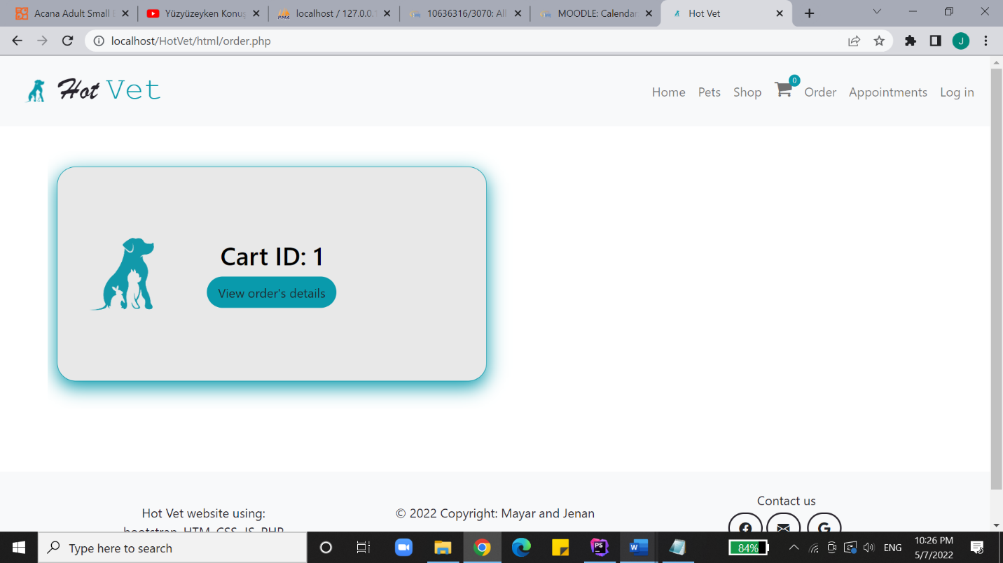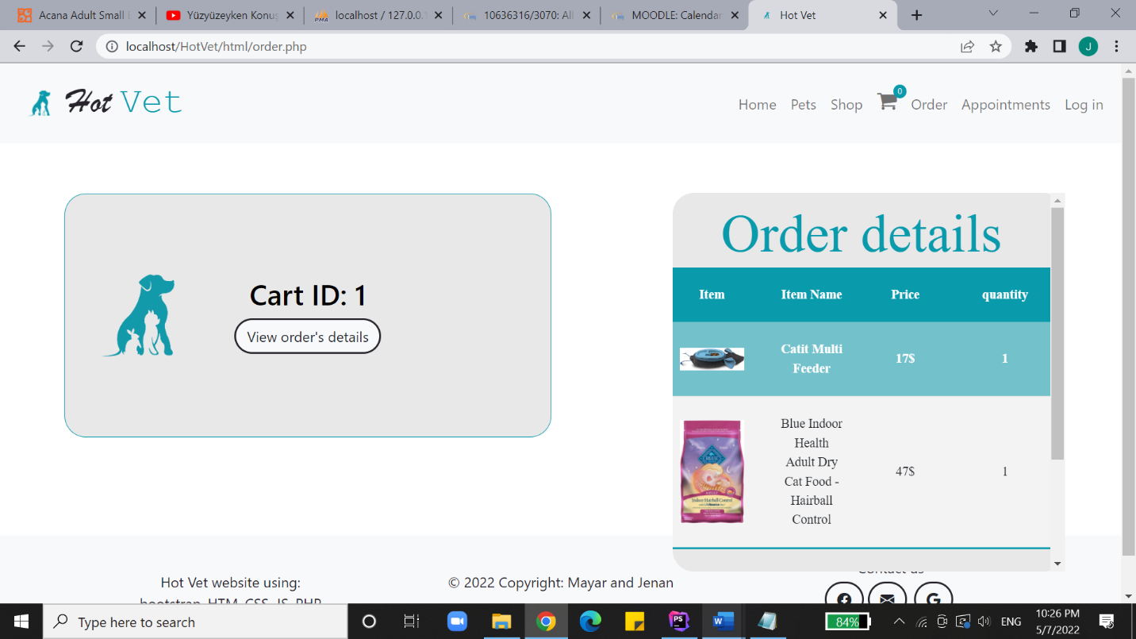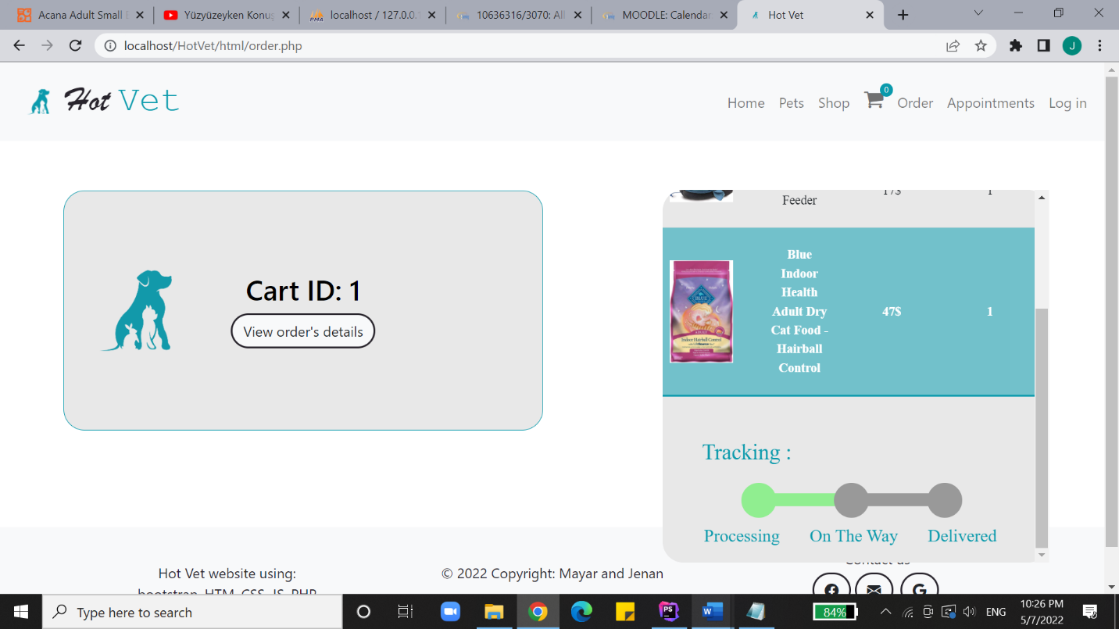

Once an order has been made, the client is capable or viewing their order’s items and track their package.

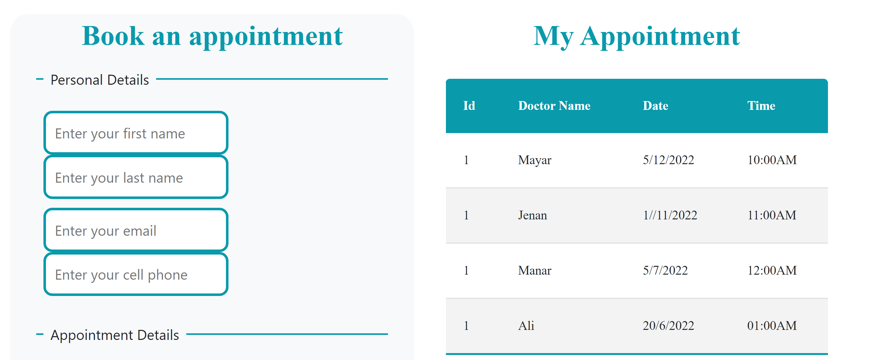

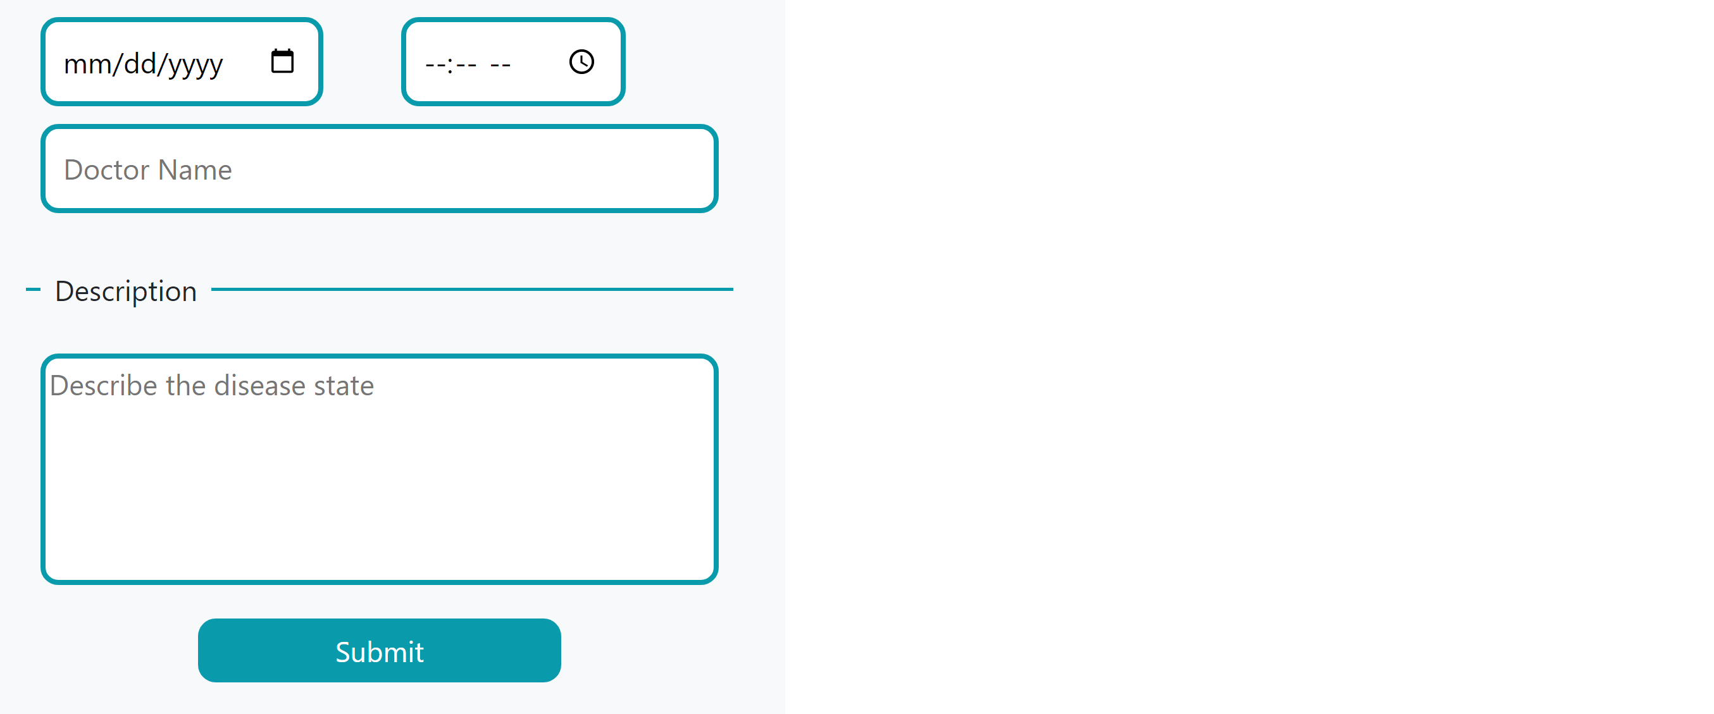

The client books an appointment with a vet using this interface by filling out all the necessary fields.

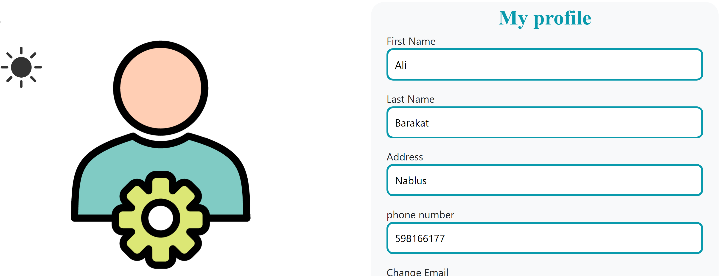

All users of different types use this interface to edit the personal data.

Employee:

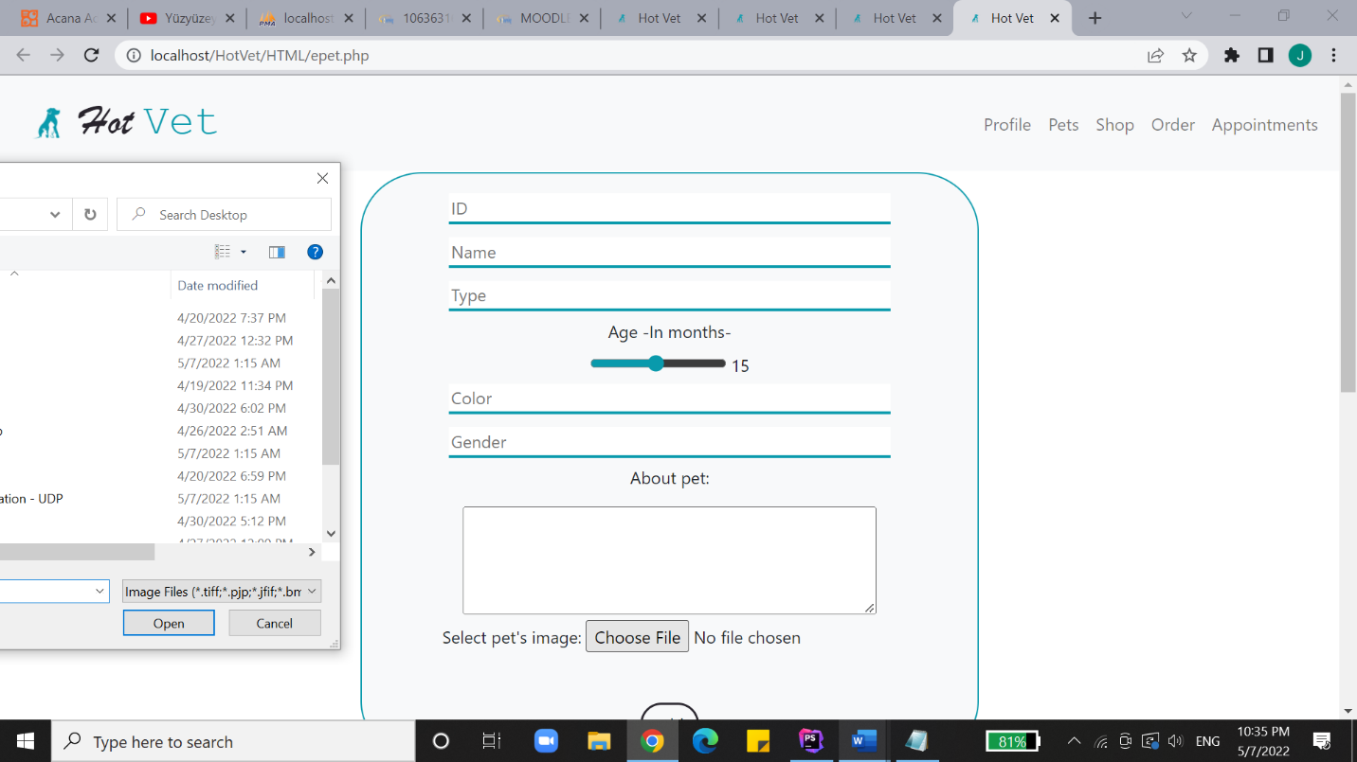

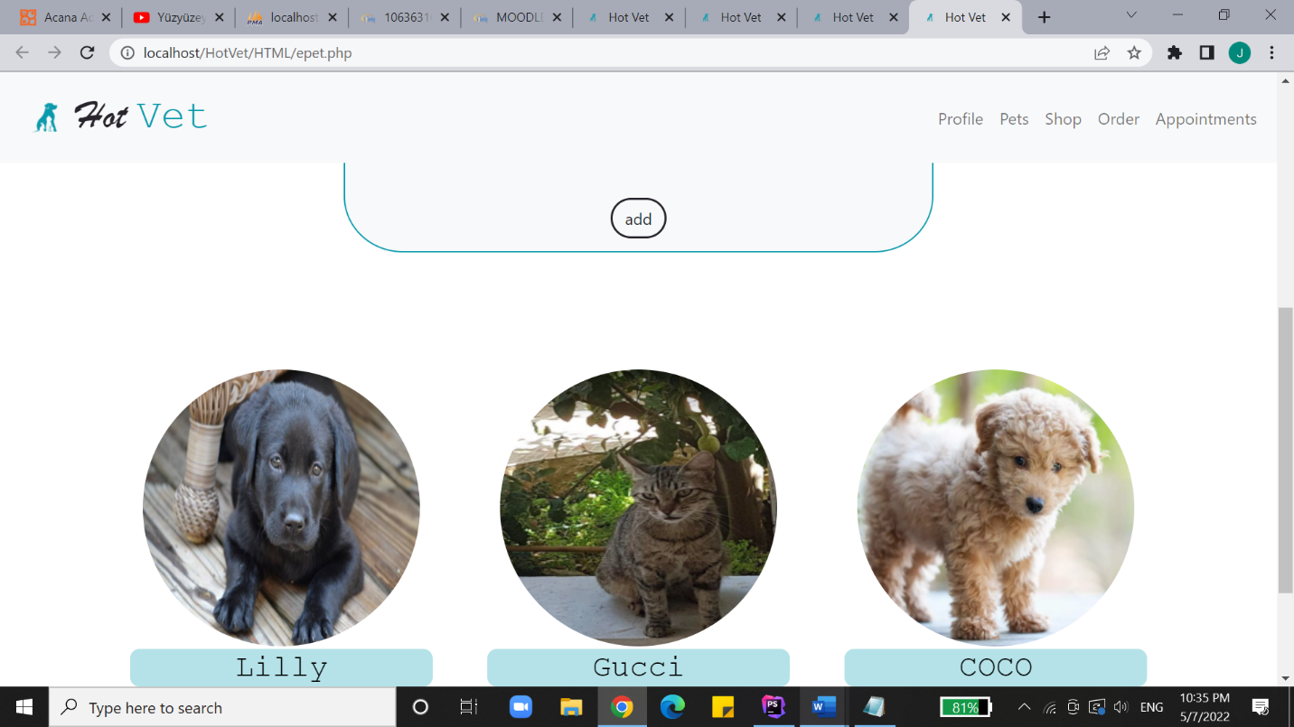

Besides viewing the pets left unadopted, the vet has the right to register new pets under the name of the clinic by entiring their specifications and uploading an image of them to be stored in the database.

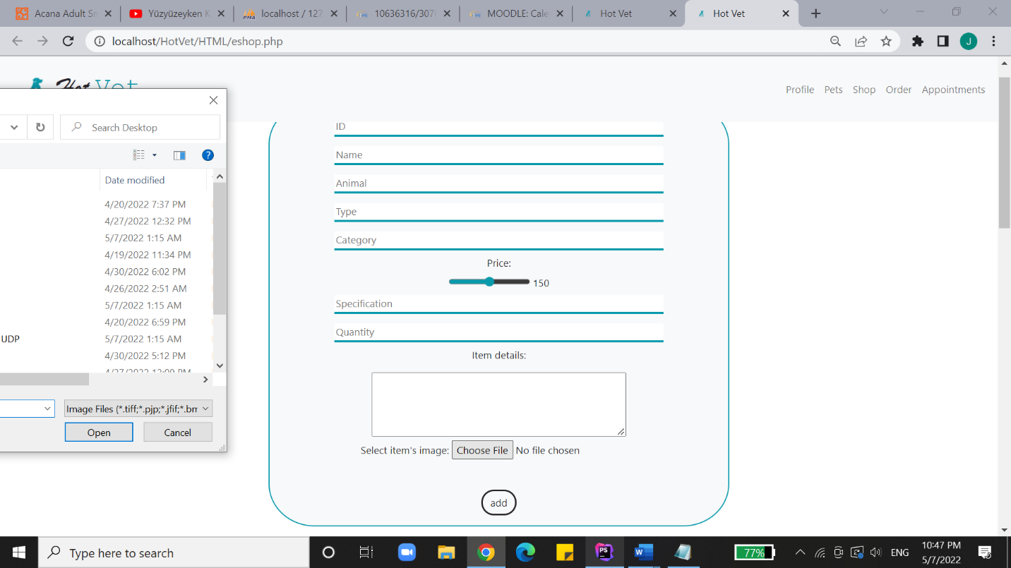

The employee can add new items by entering their data and uploading an image of each. 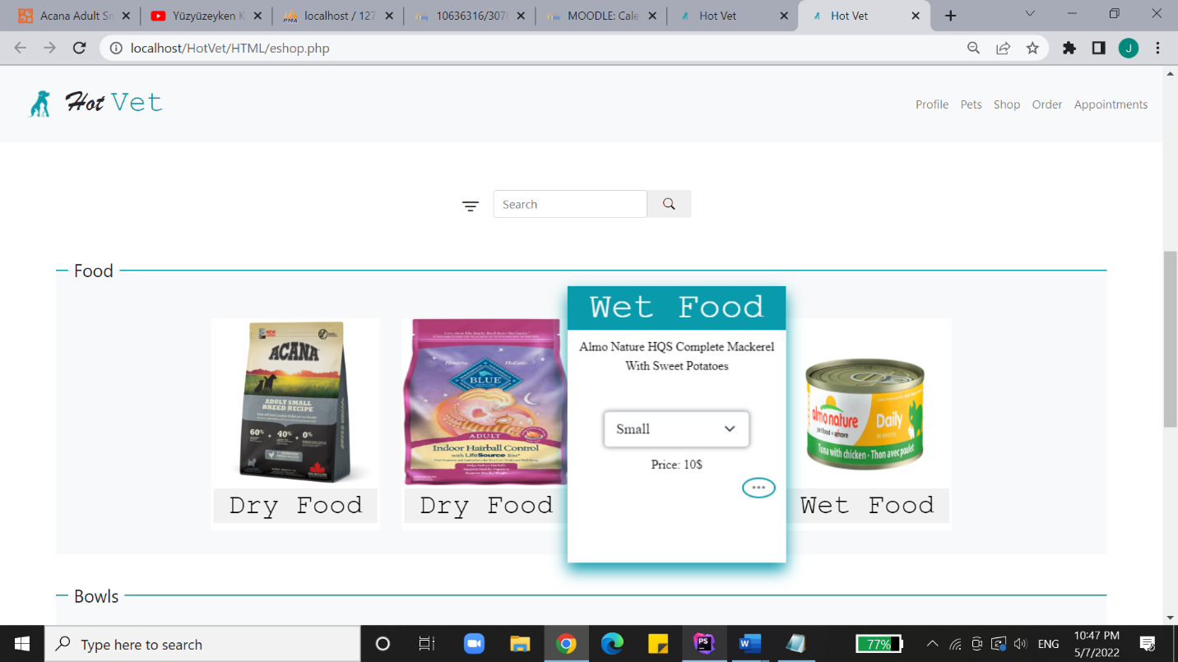

To edit a certain item, the three dots on its card are clicked then this interface appears.

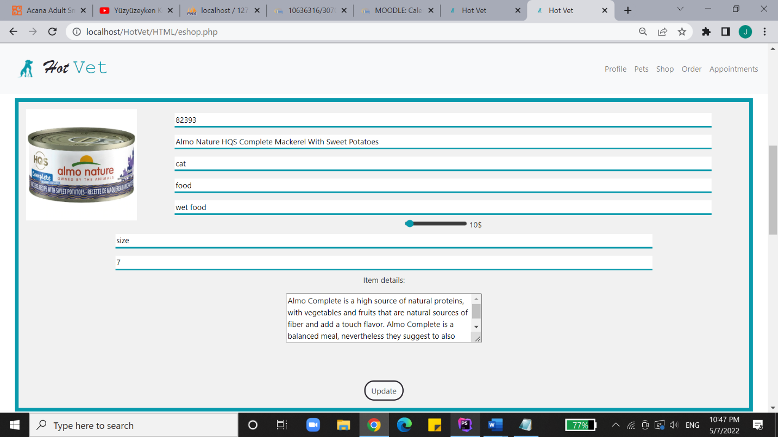

The employee edits the vallues which retrieved from the database regarding this item. Once the editing is finished, the update is reached to the database.

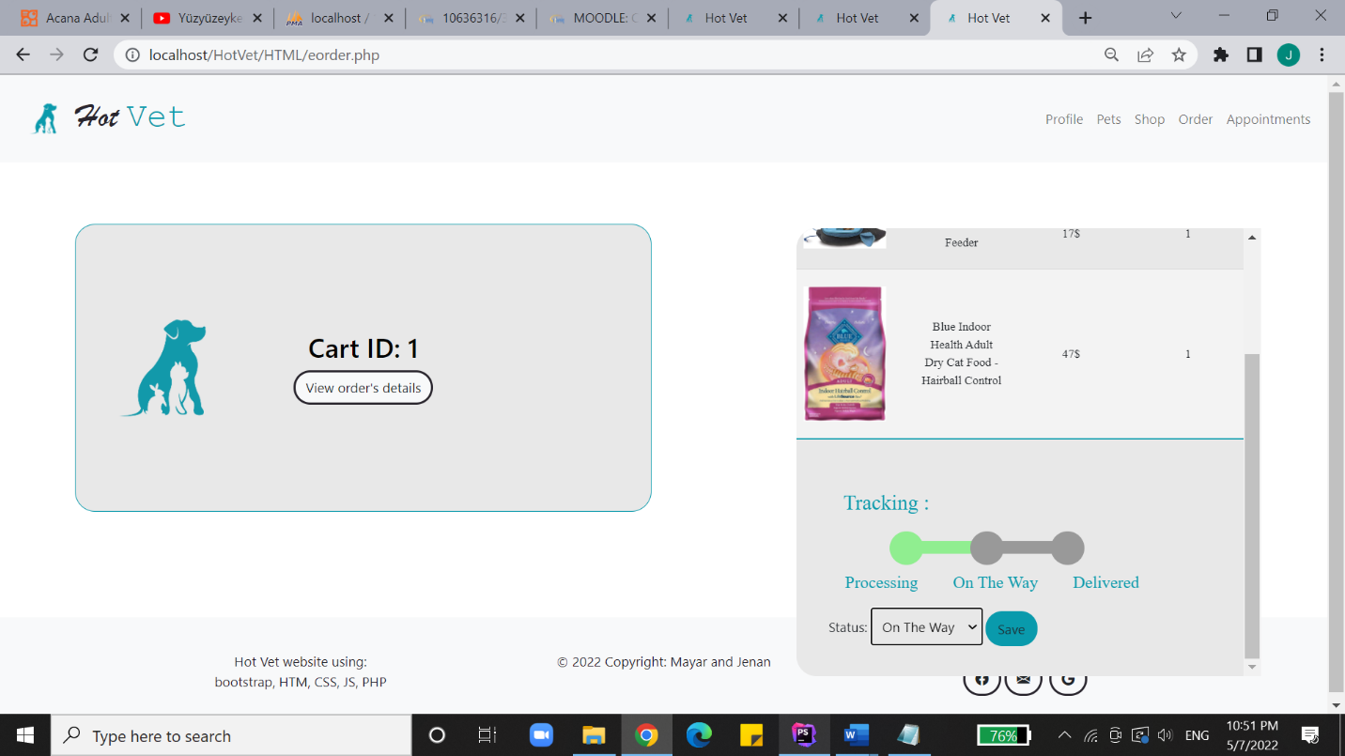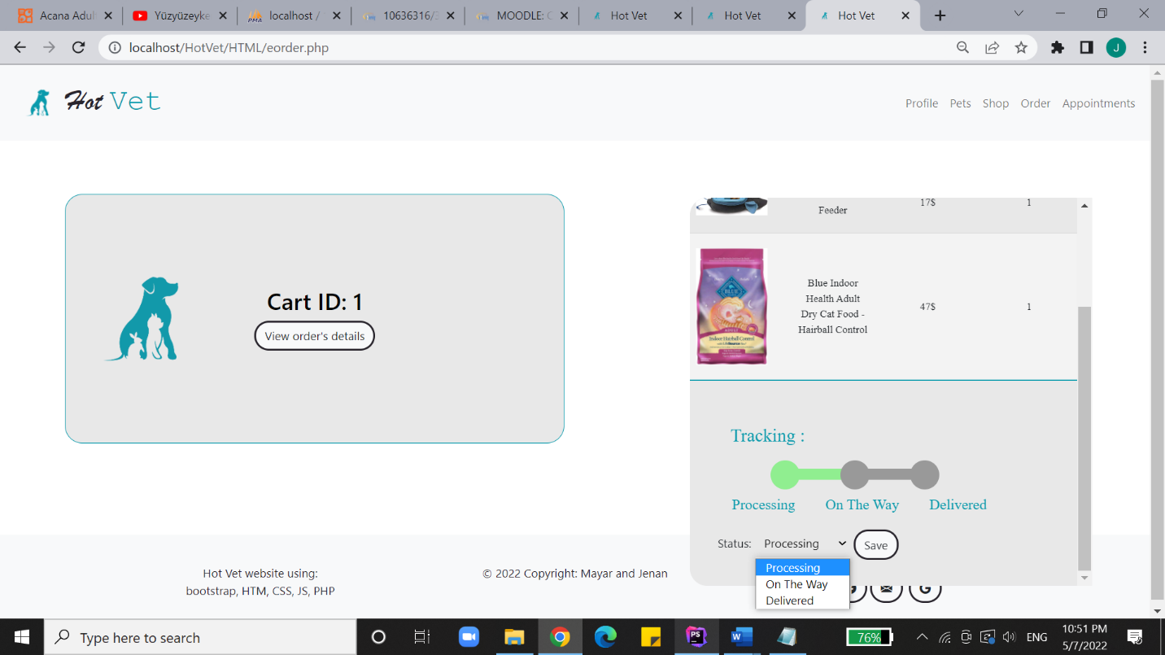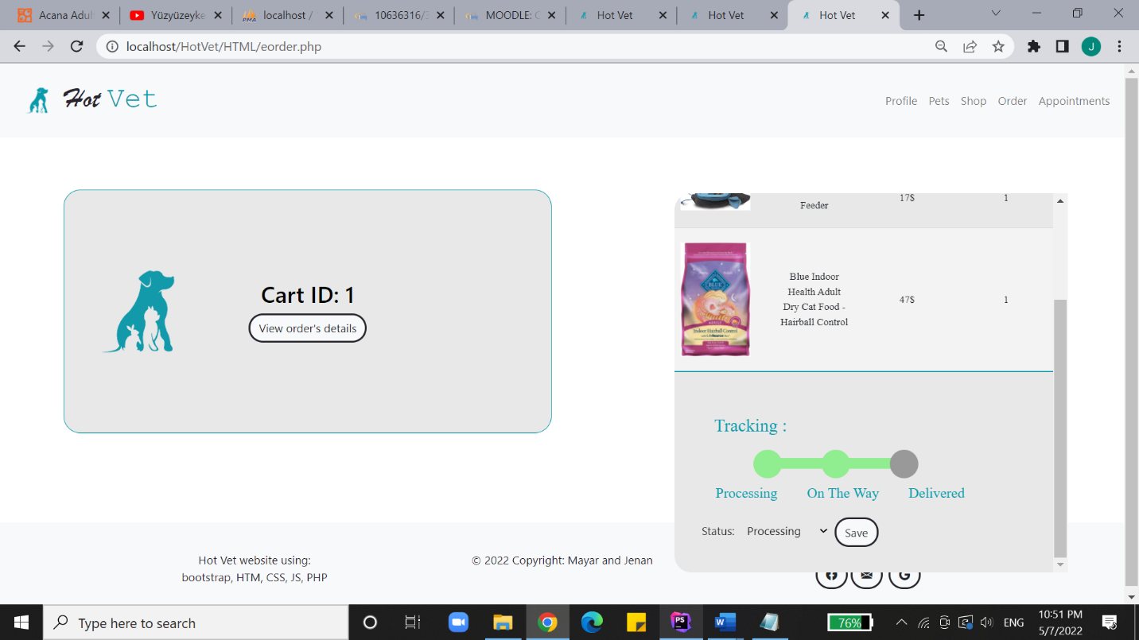

As it’s the employees’ job to update the status of ordered packages, the status is updated as the employee gets to view all orders made in the website then choosing the desired one ton update its status.

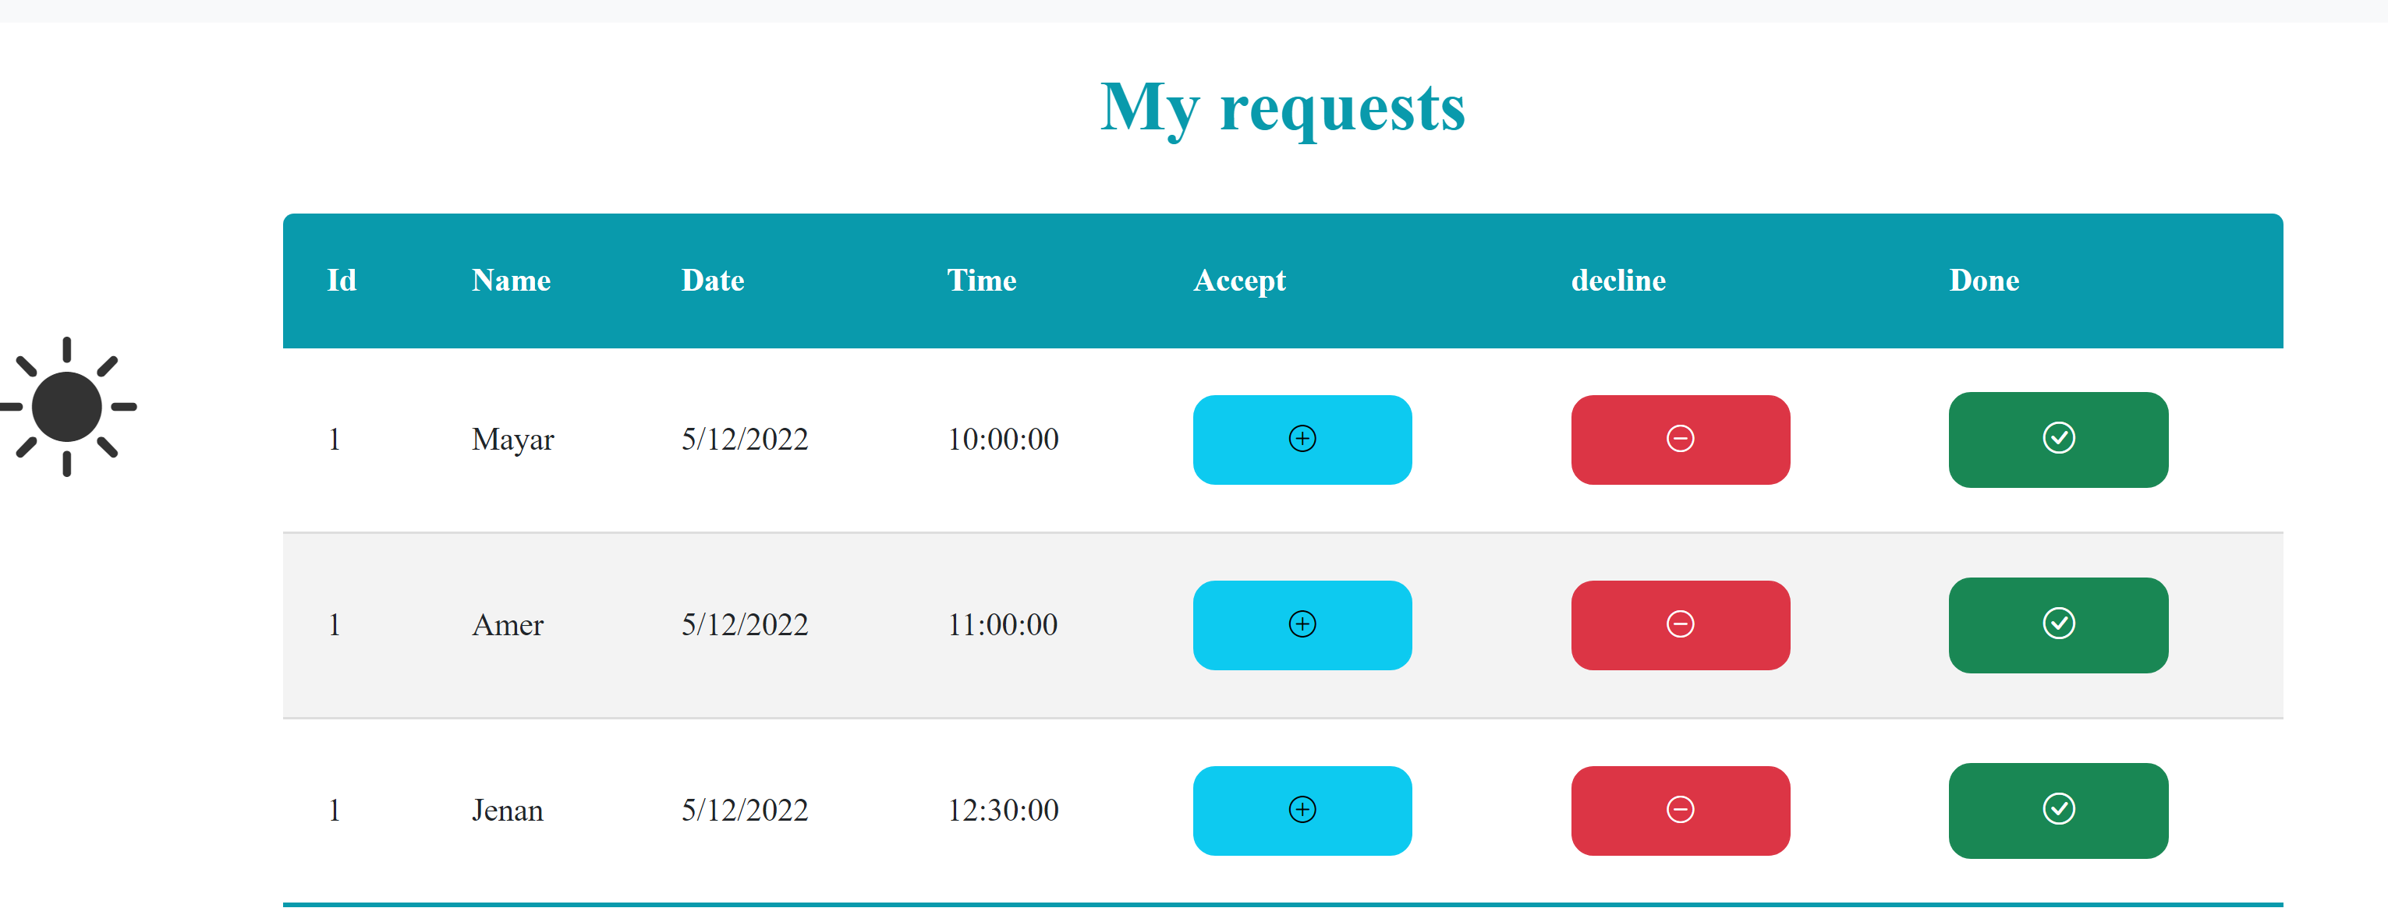

The employee gets to accept or reject the appointments requests sent by clients.

Manager:

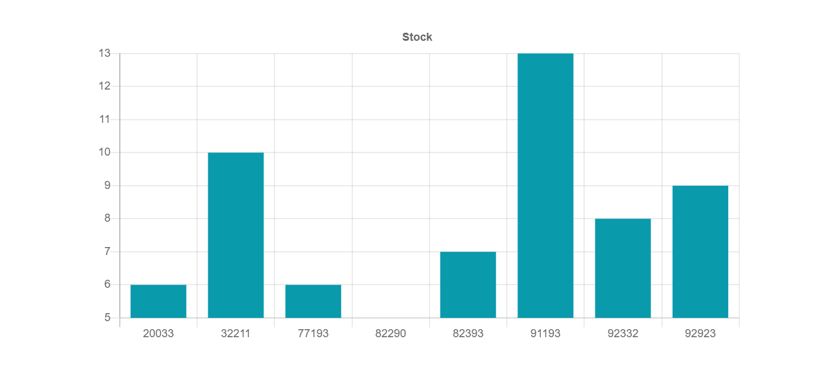

The manager gets to see a bar chart showing the left items in the stock.

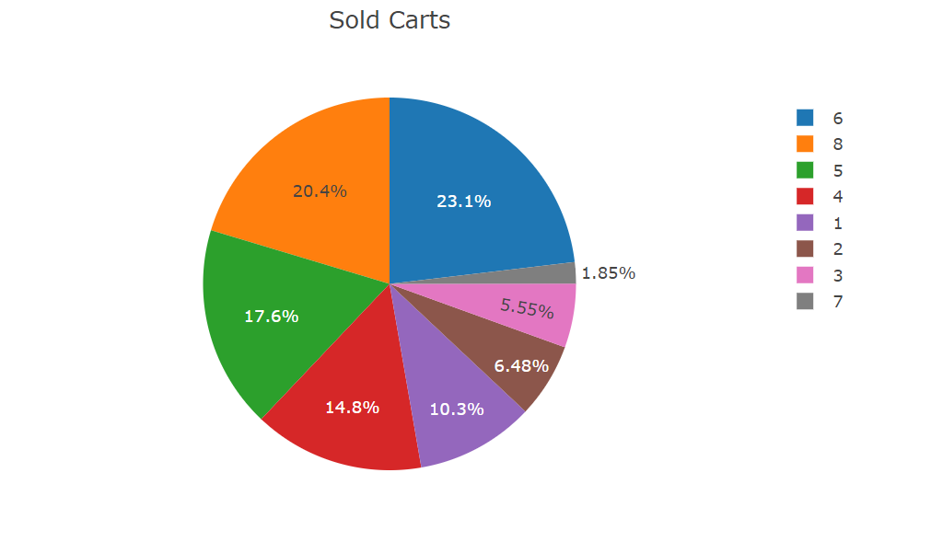

There’s also a pie chart showing the percentage of participation in the clinic’s income made by each cart as each is labeled by its id.

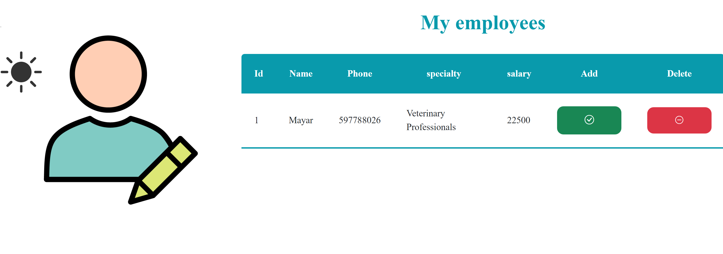

The manager is also capabale of hiring new employees to work in the clinic.

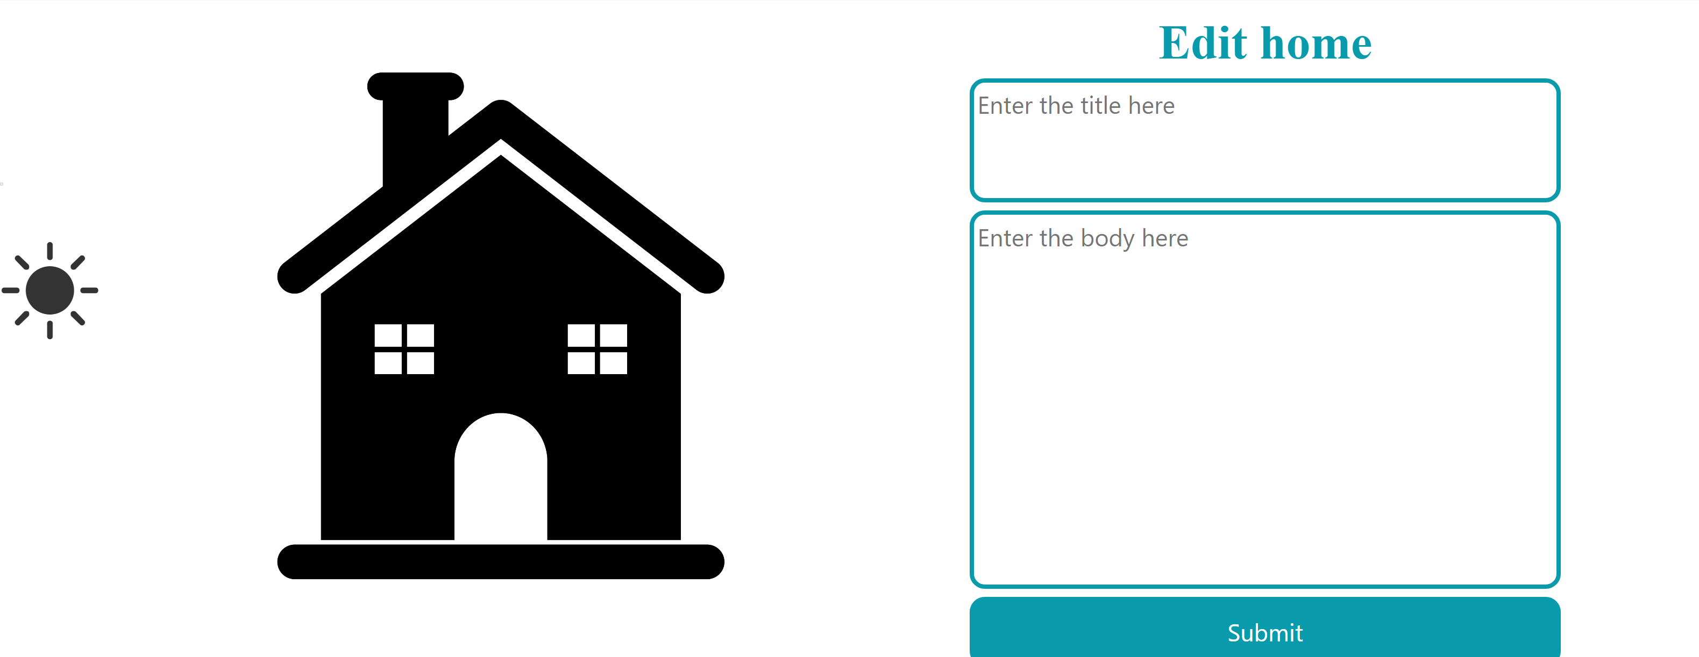

Also has the privillage to edit the home page.

General notes:

This notification bar was implemeneted using a php class built by us. Parameters are sent to define the color anf the text message to display with its title.



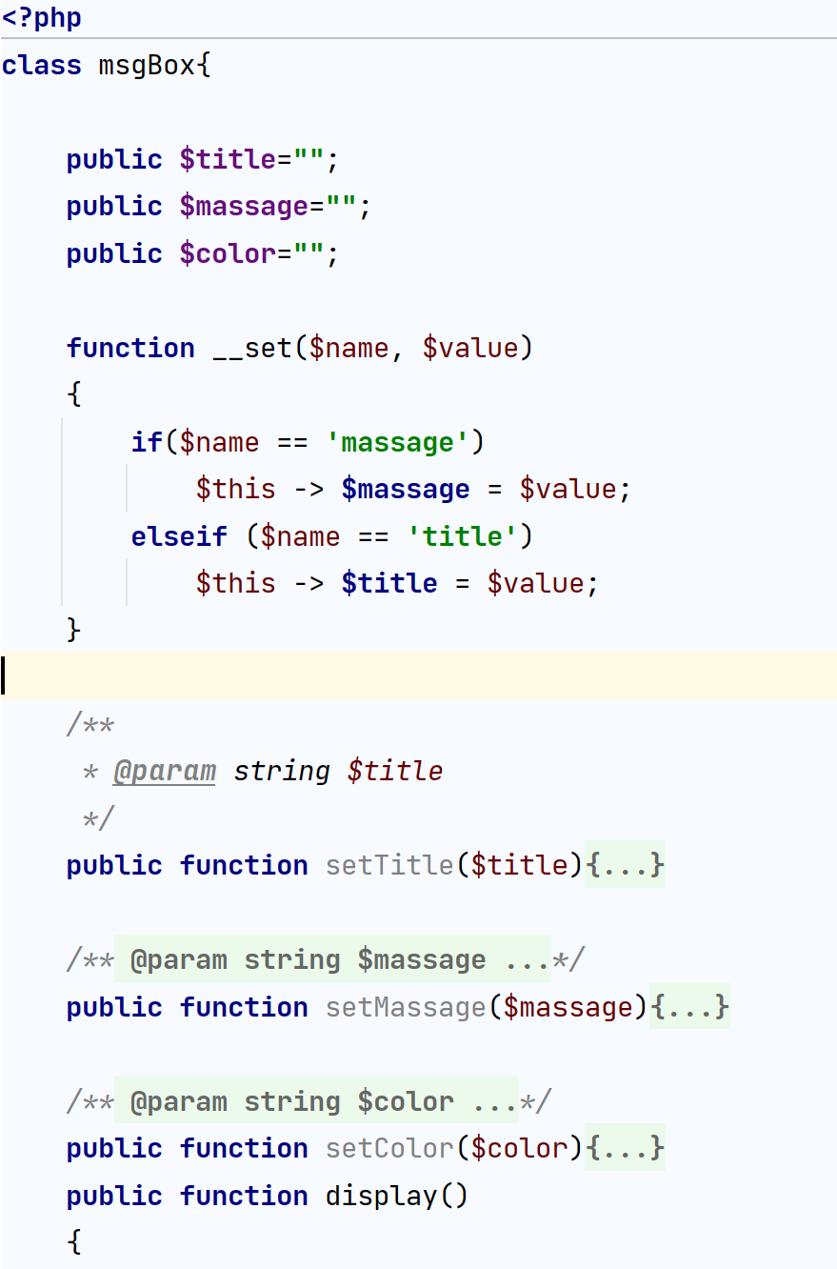

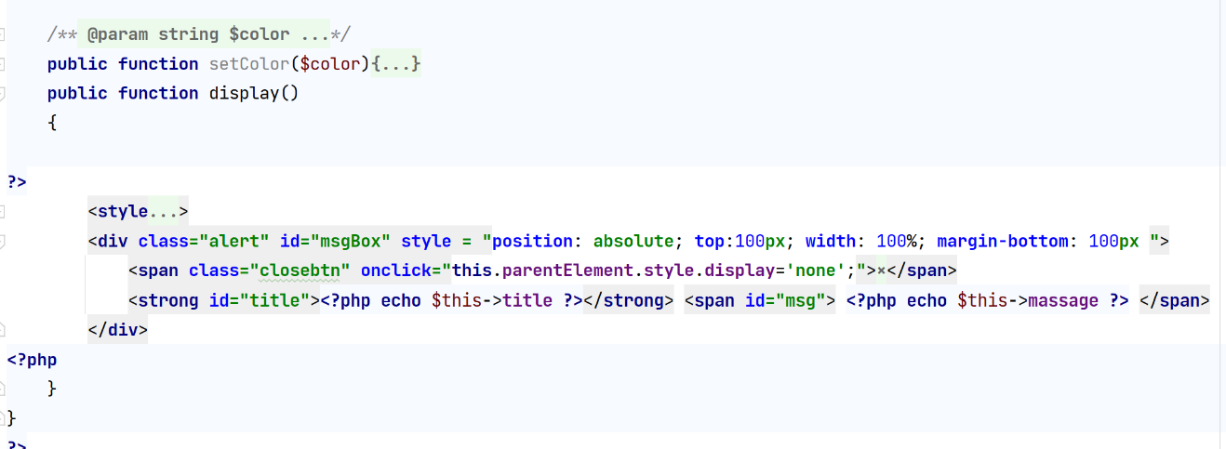

//calling

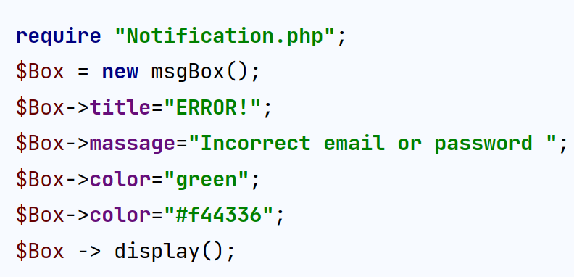

The website also supports light/dark mode property.

// light dark mode using location storage , jquery and draggable jquery ui

Some interfaces

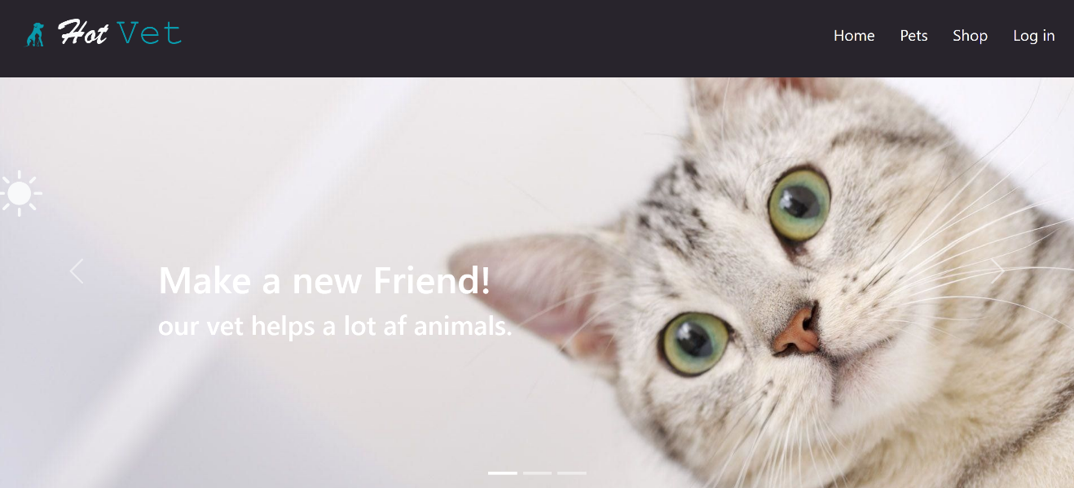

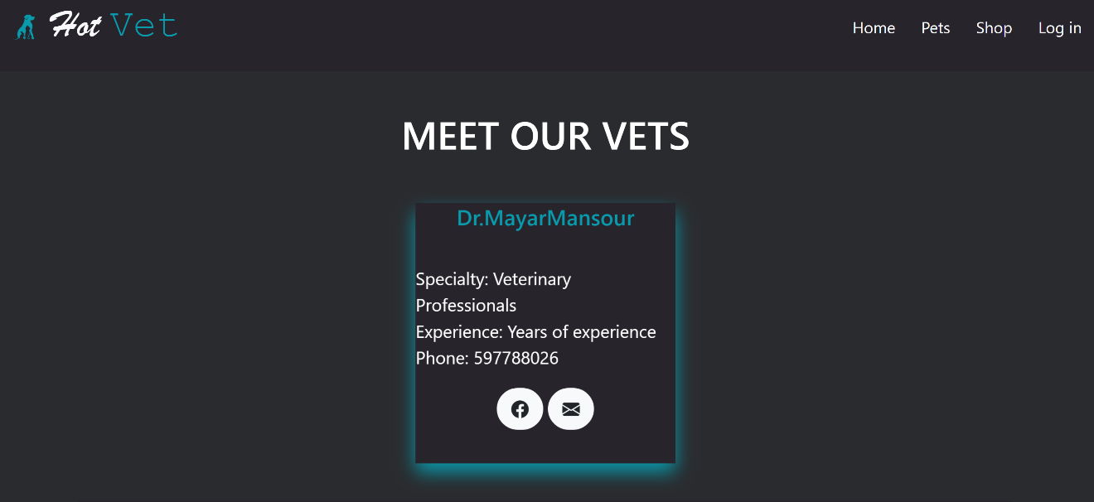

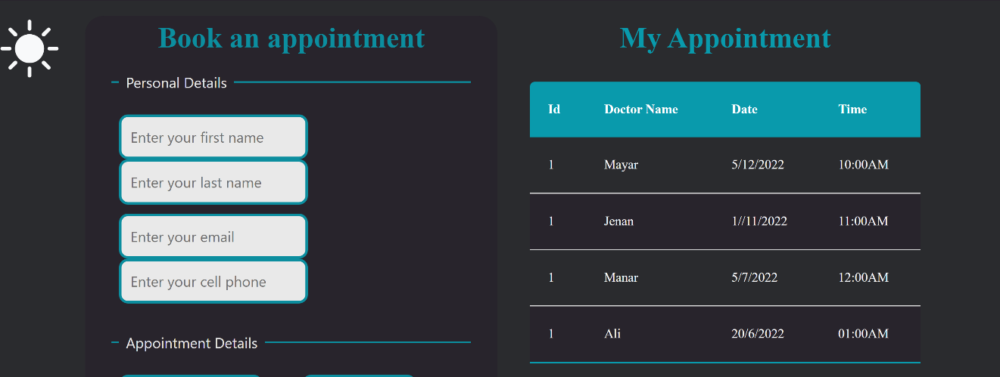

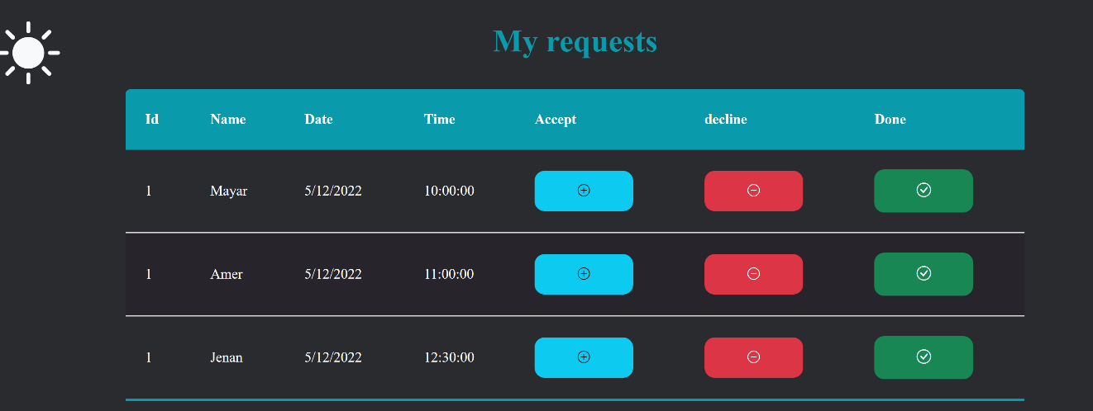

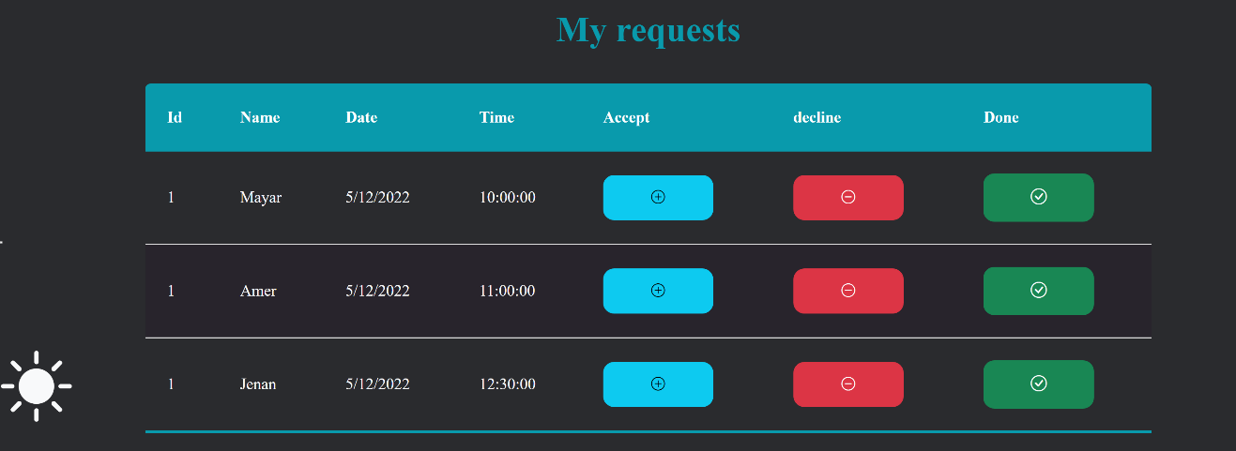

Note that the sun can be dragged over y axis.

Conclusion:

The project concludes with a practice of what we learned during the lectures. This website was developed using HTML, CSS3, PHP, Bootstrap 5, Jquery, and jQuery UI. The website implemented by us carries many special and neat properties. It helped us strengthen our knowledge in the world of web programming. Also, considering using many languages to design it, the result came out to be worth it. The website designed can be developed more in the furutre to bring more functionalities to both the client and the employee.

References:

* Web course by Dr. Sufyan Samara
* <https://www.w3schools.com/>
* <https://www.youtube.com/>
* <https://stackoverflow.com/>
* <https://www.mysql.com/?fbclid=IwAR15fq2RFHgnlXeeJc0xewMtlncroYuem-79azDY2Ev3PFlis103FoofUP0>
* <https://www.flaticon.com/?fbclid=IwAR10oTLT0xSgyXxAGvc0W8uOqBUVkpj1QiZ5Ya572WEF0N6IqiNXbLEjAtE>
* <https://www.youtube.com/watch?v=GM6dQBmcXg>
* https://www.youtube.com/watch?v=X1ulCwyhCVM&list=PLDoPjvoNmBAzjsz06gkzlSrl&fbclid=IwAR3qCa-WzHDx7WXCGQL2Y-01HrbVeSigTvOThBgMZtptFOSM7r4K28ypSnw